**Name: Atharv Sanjay Parab**

**Class: T.Y.B.SC(Computer Science)**

**Roll No: S2017005**

**Subject: Cyber Forensic**



**Manisha Education Trust’s**

**Smt. Janakibai Rama Salvi College of Arts, Commerce & Science**

**Manisha Nagar, Kalwa (W), Thane-400605**

**(ISO 9000:2008 Certified College)**

**NAAC Accredited ‘B’ Grade**

Certificate

**SUBJECT: - _______________________________**

**Class:TYBSC(CS)**

**Year: 2019 - 2020**

This is to certify that the work entered in this journal is the work of Shri ­­­­**­Atharv Sanjay Parab**­­ who has worked for the Semester-VI. This file was submitted for TYCS Semester-VI Practical Examination.

Head of Dept. Internal Examiner External Examiner

Date of Submission: / /

College Seal:

|  |  |  |  |
| --- | --- | --- | --- |
| PRACTICAL **NO** | PRACTICAL Name | Date | Signature |
| 1 | Creating a Forensic Image using FTK Imager/Encase Imager. | 22.01.2020 |  |
| 2 | **Data Acquisition: Perform data acquisition using: USB Write Blocker + FTK Imager** | 6.12.2019 |  |
| 3 | Forensics Case Study: Solve the Case study (image file) provide in lab using Encase Investigator or Autopsy. | 30.01.2020 |  |
| 4 | **Capturing and analyzing network packets using Wireshark** | 6.12.2019 |  |
| 5 | Analyze the packets provided in lab and solve the questions using Wireshark | 12.12.2019 |  |
| 6 | Using Sysinternals tools for Network Tracking and Process Monitoring | 17.02.2020 |  |
| 7 | Recovering and Inspecting deleted files | 01.02.2020 |  |
| 8 | Acquisition of Cell phones and Mobile devices | 17.02.2020 |  |
| 9 | **Email Forensics**   * **Mail Service Providers** * **Email protocols** * **Recovering emails** | 17.02.2020 |  |
| 10 | **Web Browser Forensics.**  **-Web Browser working**  **-Forensics activities on browser**  **-Cache / Cookies analysis** -Last Internet activity | 24.02.2020 |  |

**PRACTICAL 1**

**Aim**: Creating a Forensic Image using FTK Imager/Encase Imager.

**Info**:**FTK** **Imager** is a data preview and imaging tool used to acquire data (evidence) in a forensically sound manner by creating copies of data without making changes to the original evidence.

Steps:

* Creating Forensic Image
* Check Integrity of Data
* Analyse Forensic Image

➢Creating Forensic Image

* 1. Click File, and then Create Disk Image, or click the button on the tool bar.

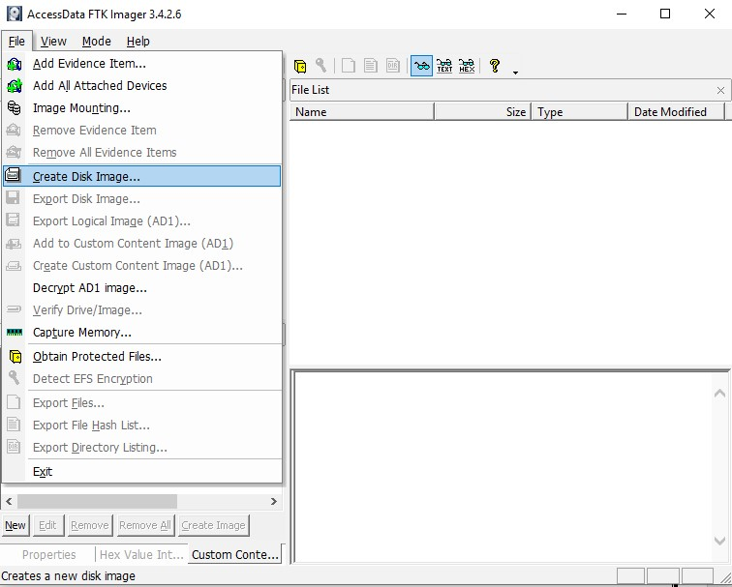

* 1. Select the source evidence type you want to make an image of and click Next.

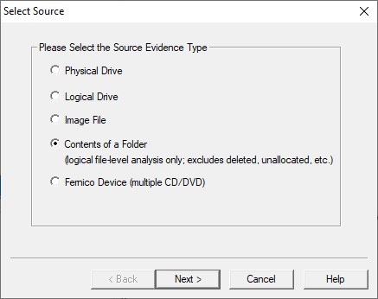

* 1. Select the source evidence file with path .

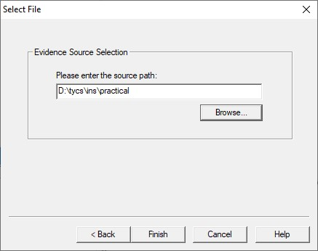

Click on “add” to add image destination

w

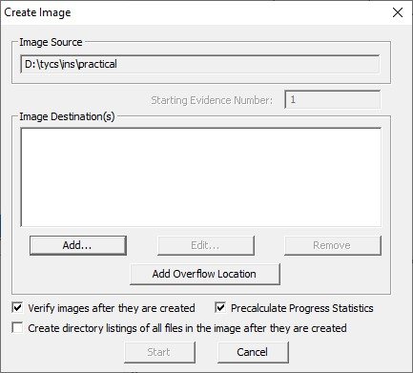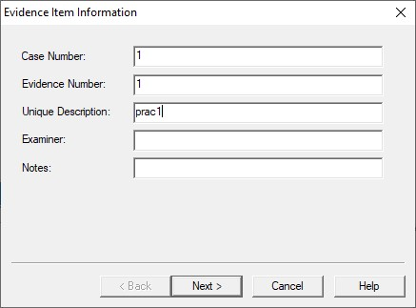

* 1. In the Image Destination Folder field, type the location path where you want to save the image file, or click **Browse** to find to the desired location.

**Note:** If the destination folder you select is on a drive that does not have sufficient free space to store the entire image file, FTK Imager prompts for a new destination folder when all available space has been used in the first location.In the Image Filename field, specify a name for the image file but do not specify a file extension.

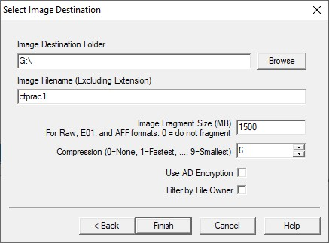

* 1. After adding the image destination path click on finish and start the image processing.

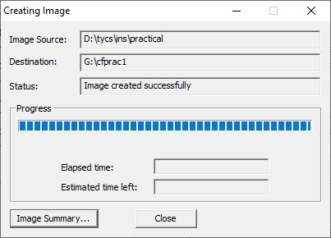

* 1. After the images are successfully created, click Image Summary to view detailed file information, including MD5 and SHA1 checksums.

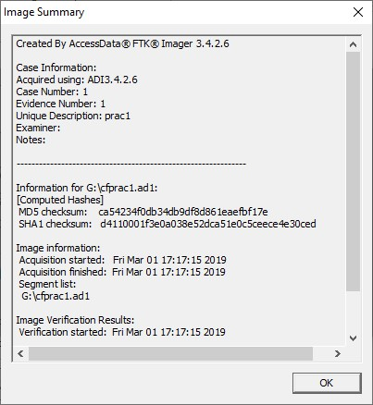

**Analyze Forensic Image:**

Click on Add Evidence Item to add evidence from disk, image file or folder.

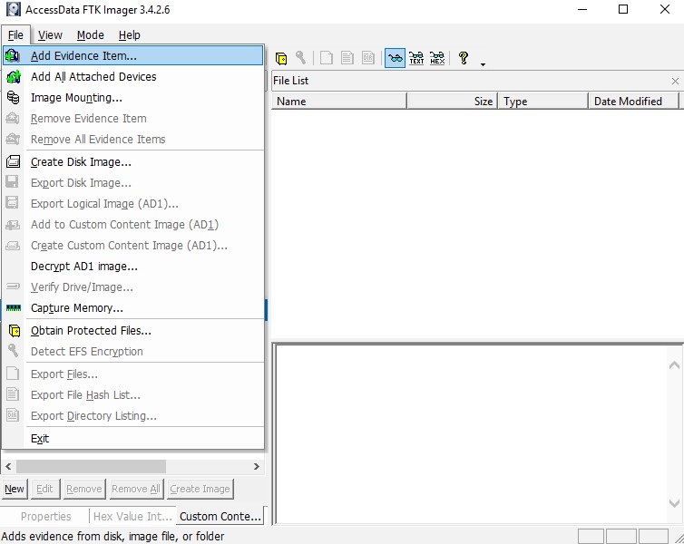

Now select the source evidence type as image file.

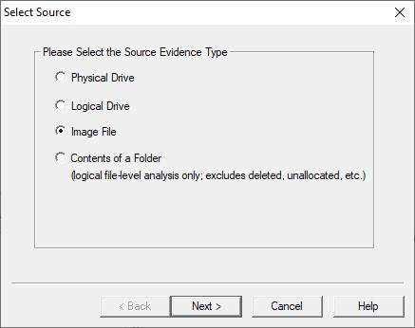

Open the created evidence image file

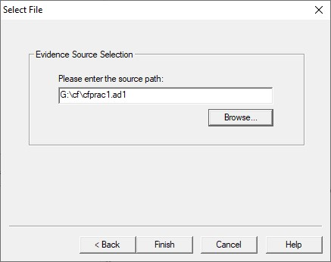

Now select Evidence Tree and analyze the image file .

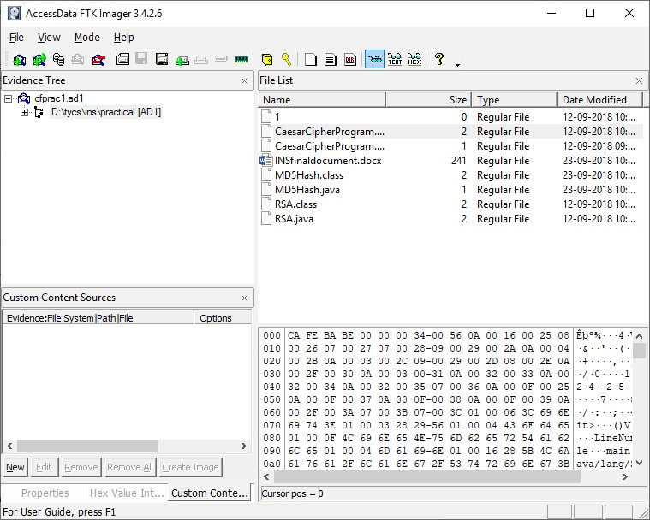

**PRACTICAL 2**

Aim: Data Acquisition:

* Perform data acquisition using:
* USB Write Blocker + FTK Imager

**INFO:**ProDiscover suite of products addresses a wide range of scenarios handled by law enforcement organisations and corporate internal investigations. ProDiscover provides a rich set of features and toolkits for Computer Forensics and Incident Response. The product suite is also equipped with diagnostic and evidence collection tools for corporate policy compliance investigations and electronic discovery.

**Steps:**

Step 1: First Open Prodiscover Basic and start with new case.

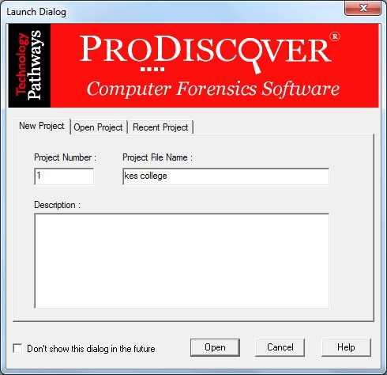

Step 2: The created project appears in left pane and select add>capture & add image.

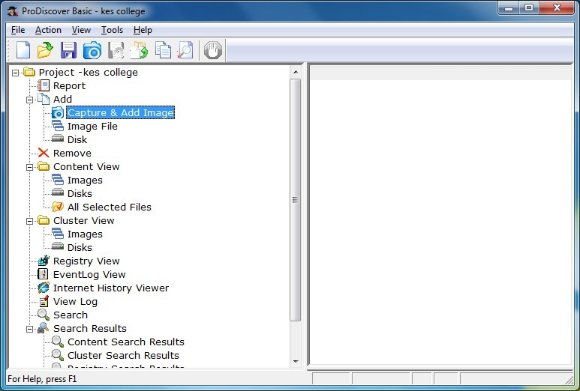

Step 3: fill the details as below. And click ok.

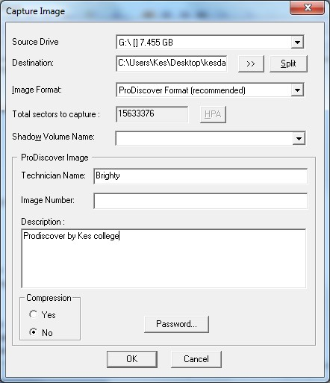

Step 4: capturing of image starts.

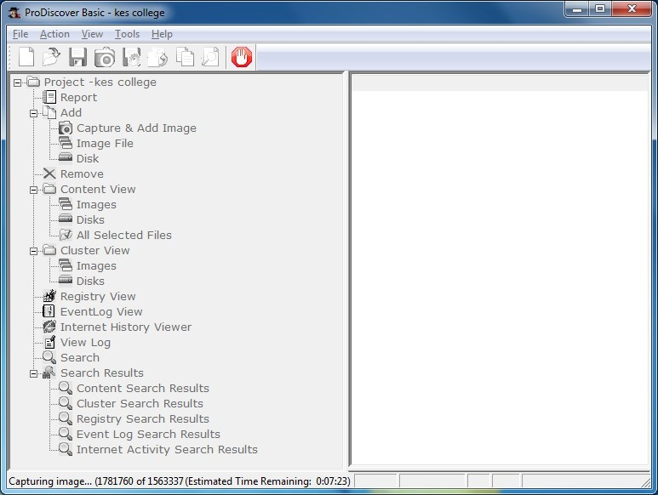

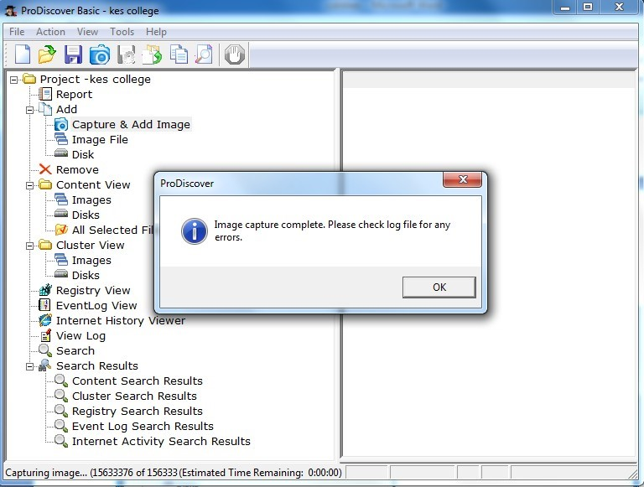

Step 5: Open the image created, go to Add > Images in left pane.

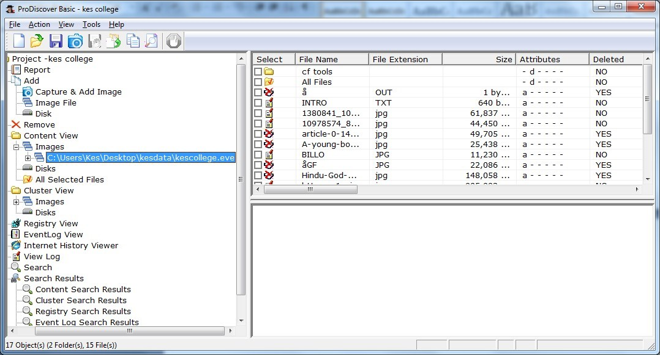

Step 6: Click on any File and type a comment.

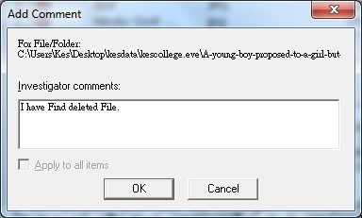

Step 7 : the cluster view is seen from the cluster view in left panel.

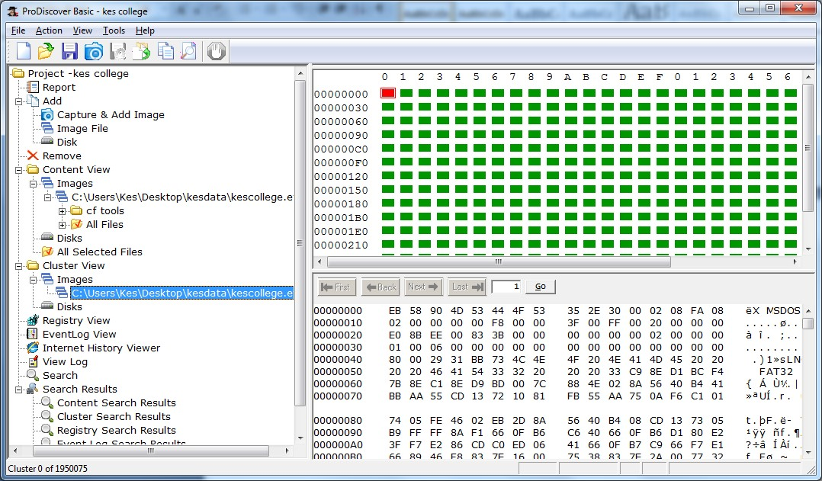

Step 8 : We can also view gallery view by Right Click.

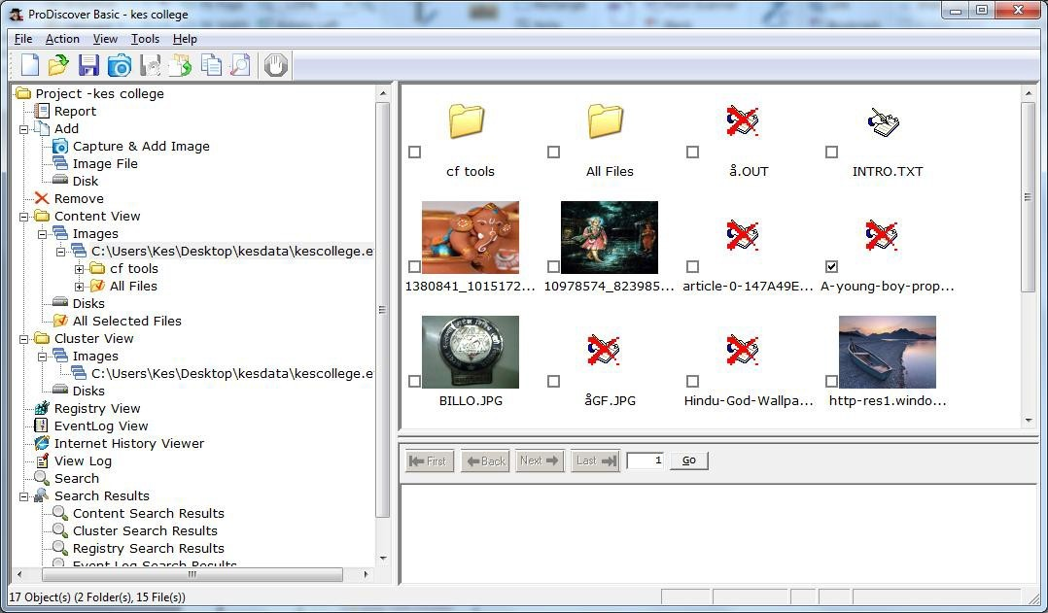

Step 9: Keyword search. Click on Search in left pane and Enter the file name to be searched in the image created.

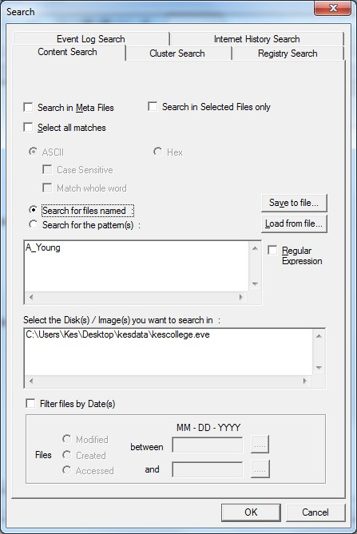

Step 10 : Output of Keyword search.

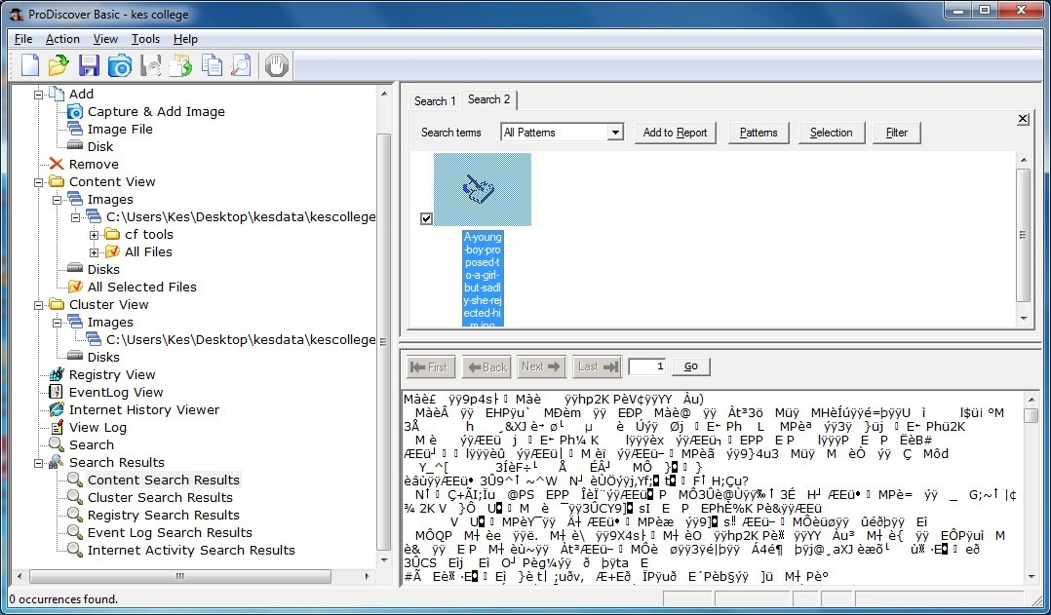

Step 11 : Click on View>Report.

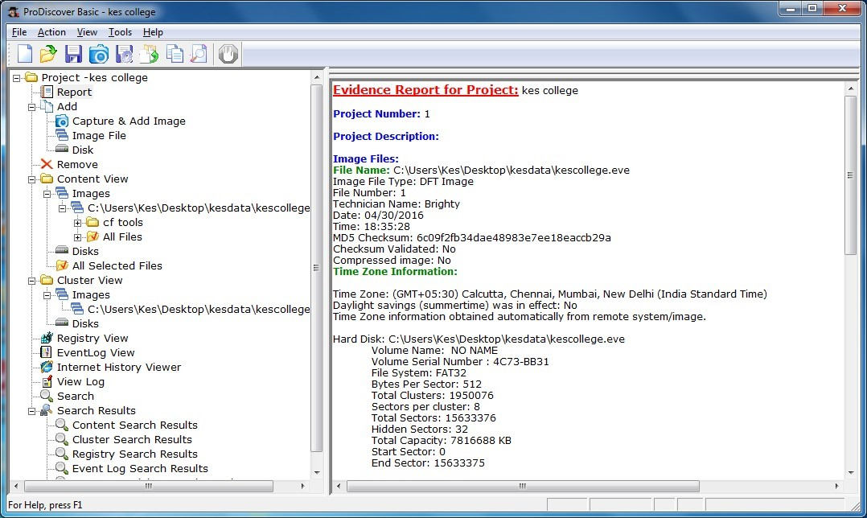

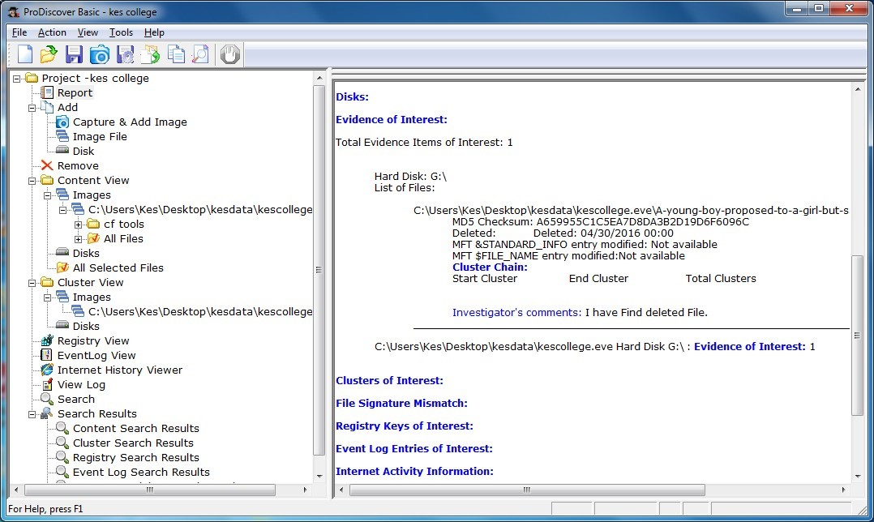

# PRACTICAL 3

**AIM:** Forensics Case Study: Solve the Case study (image file) provide in lab using Encase Investigator or Autopsy.

**INFO:**Autopsy is computer software that makes it simpler to deploy many of the open source programs and plugins used in The Sleuth Kit. The graphical user interface displays the results from the forensic search of the underlying volume making it easier for investigators to flag pertinent sections of data

**Steps:**

Step 1: Open Autopsy

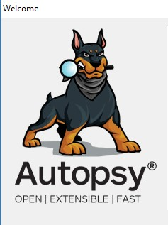

Step 2 : Click on new case

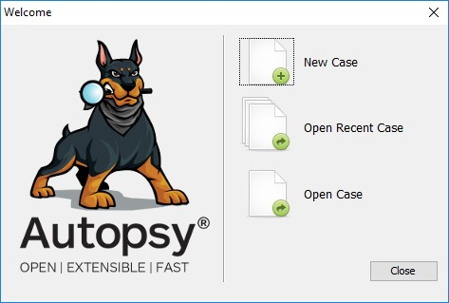

Step 3 : Enter details regarding the case and click on next button.

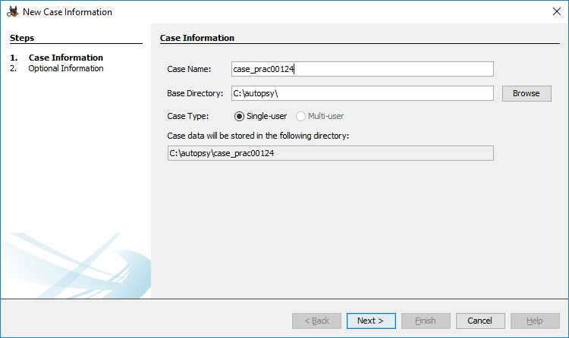

Step 4 : Enter further details and click on next button

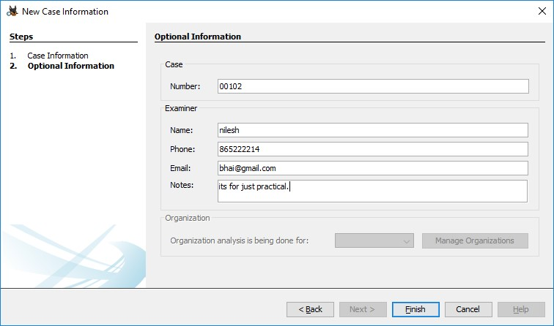

Step 5 : Now here we have to select Type of data source to add , in our case disk image or VM file and click on next

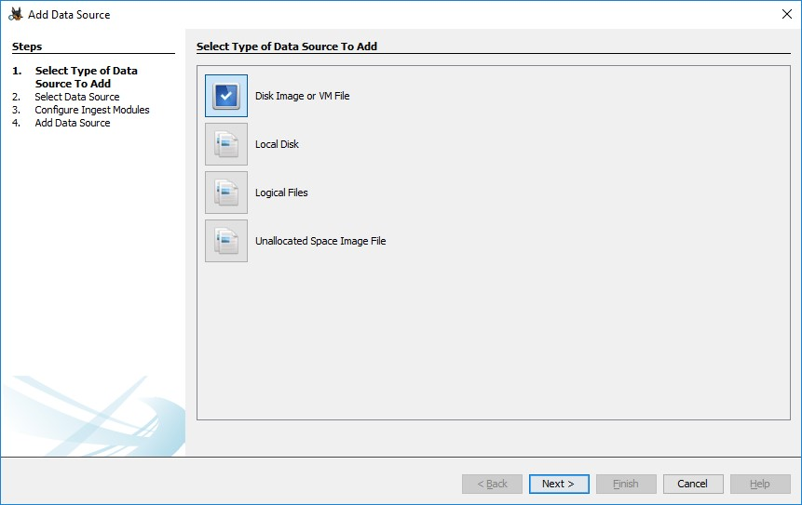

Step 6 : Now we have to select image file and click on next button

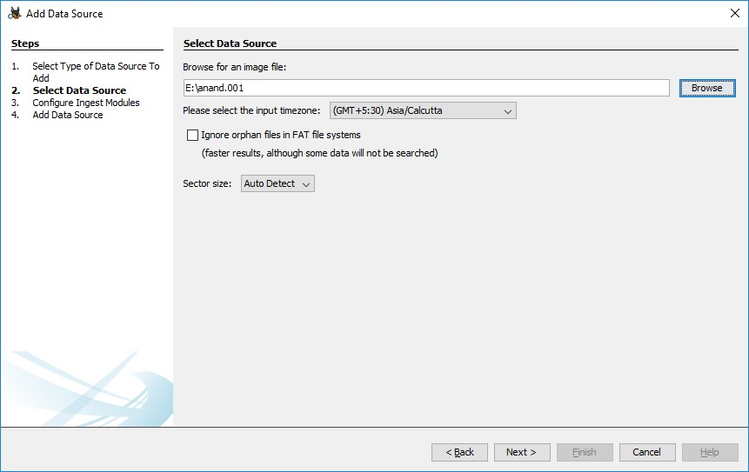

Step 7 : Now click on select all in order to Run ingest modules on: and click on next.

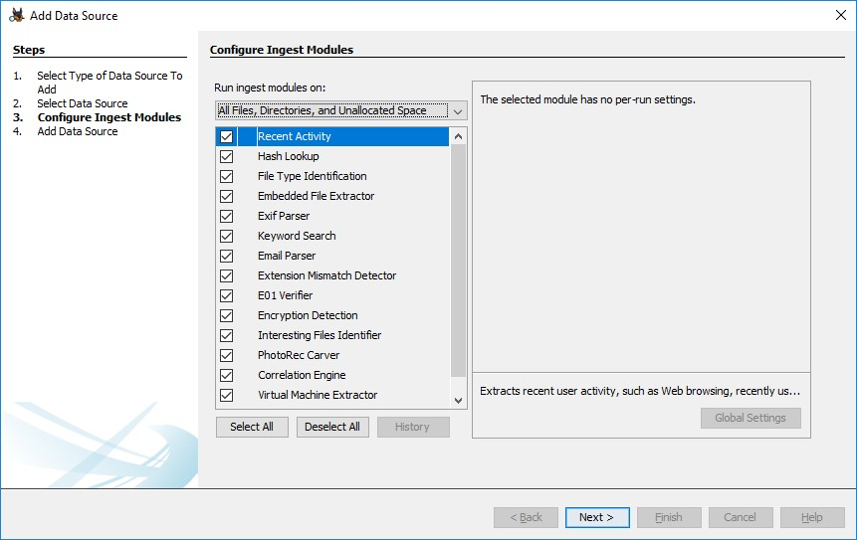

Step 8 : Now click on finish

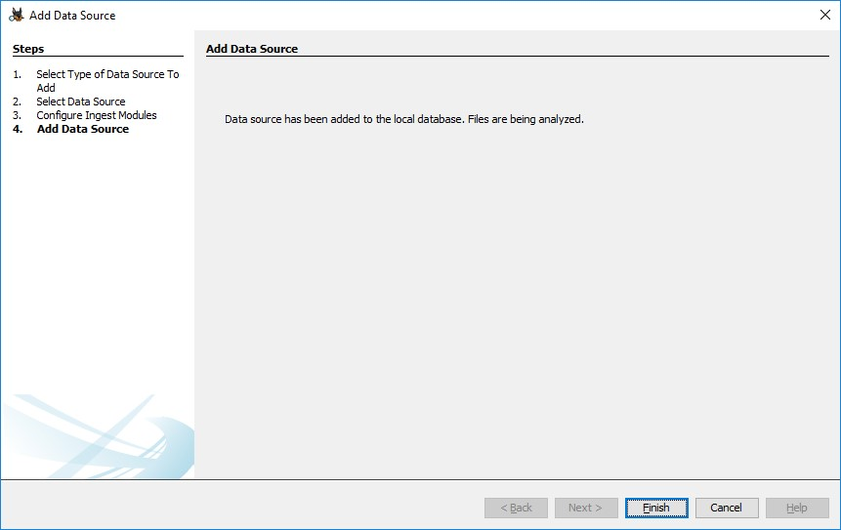

Step 9 : Now Autopsy window will appear and it will analyse the disk that we have selected .

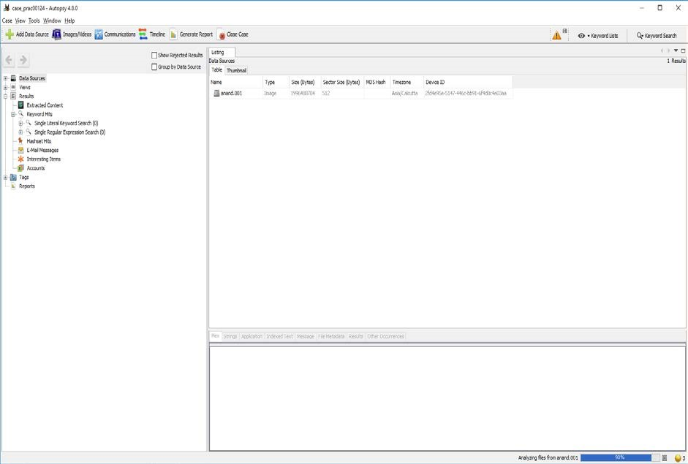

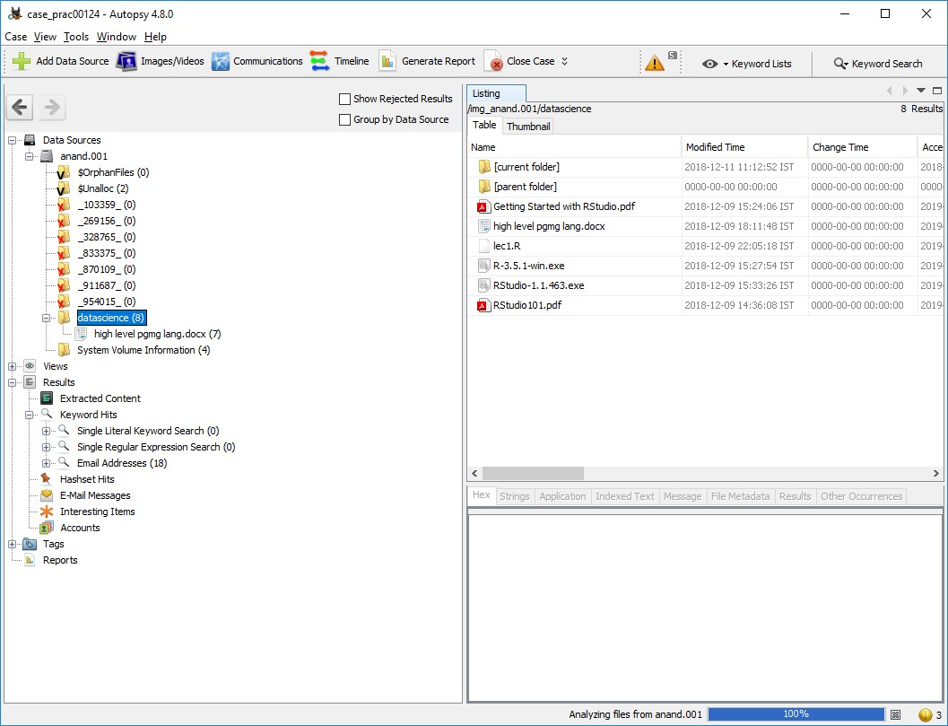Step 10 : All image files appears in the Table tab. Select any file to see the data

Step 11 : Expand the tree from left side panel to view the document files.

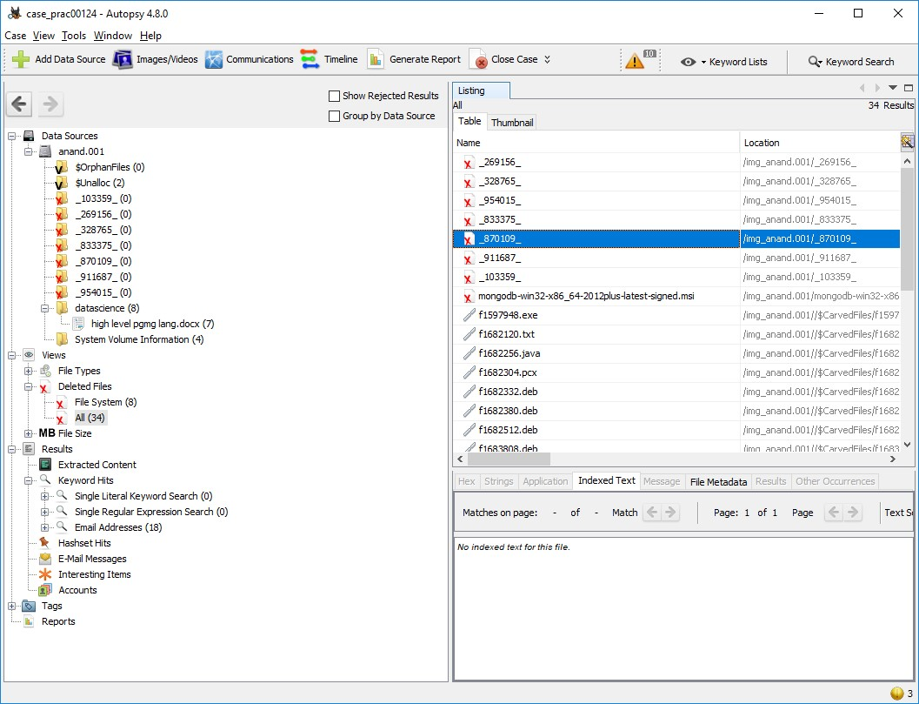

Step 12 : To recover the files , go to view code → Deleted files node , here

select any file and right click on it then select Extract files option

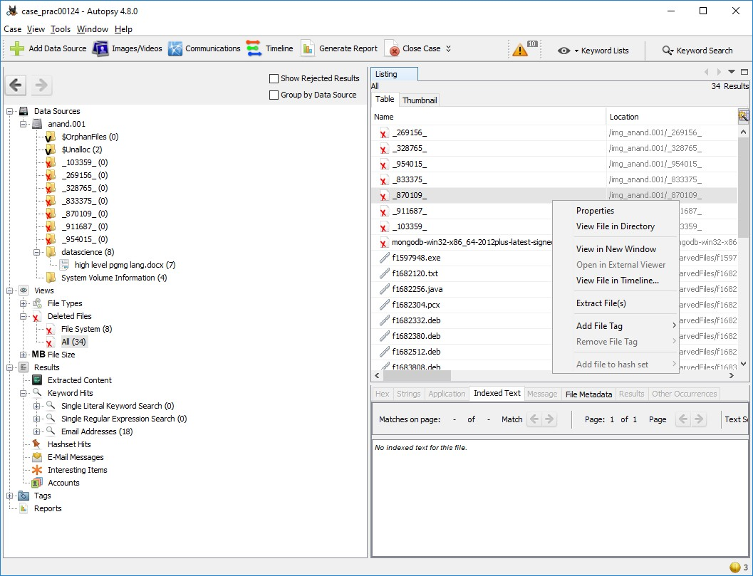

Step 12: Select Path where you want to save extracted file and click on save .

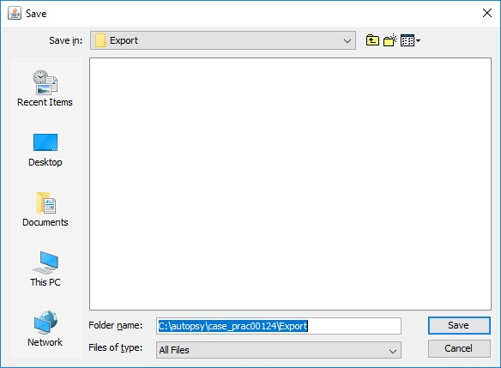

Step 13 : Now click on OK

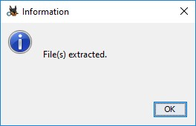

Step 14 : Now go to C:\autopsy\case_prac00124\Export folder to see recover file

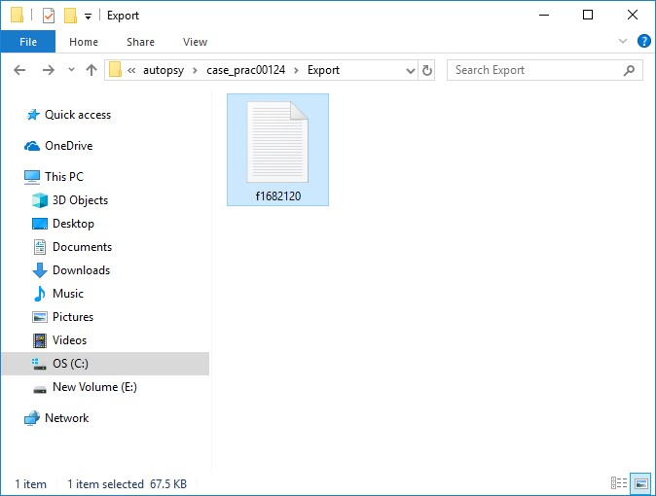

Step 15 : Click on generate report from Autopsy window and select the Excel format and click on next

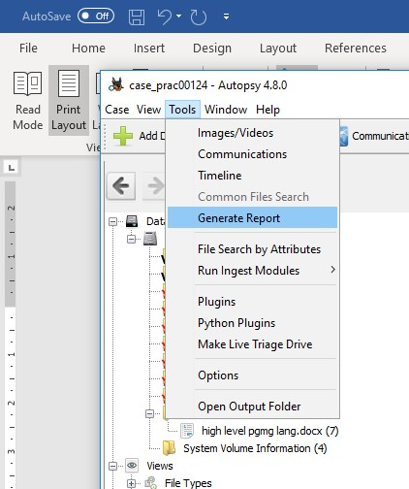

Step 16 : This window will appear

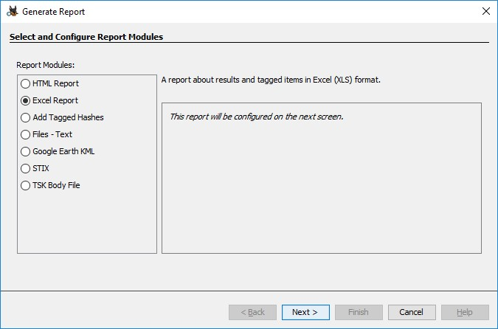

Step 17 : Now report is generated so click on close button. We can see the

Report on Report Node

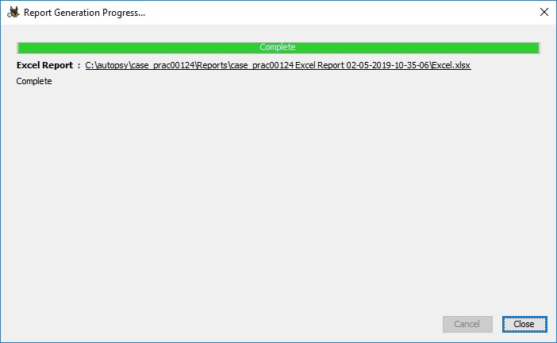

Step 18 : Click on report

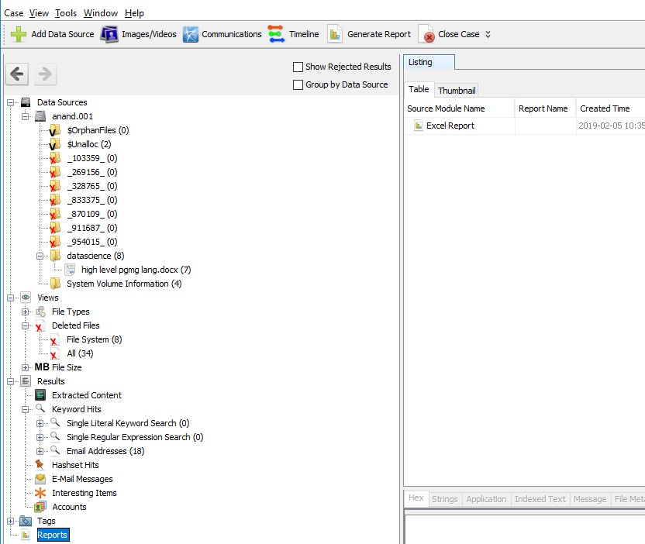

**PRACTICAL 4**

**AIM:** Capturing and analyzing network packets using Wireshark

(Fundamentals):

**INFO:** Wireshark is a free and open-source packet analyzer. It is used for network troubleshooting, analysis, software and communications protocol development, and education.

* Identification the live network
* Capture Packets
* Analyze the captured packets

**Capturing Packets**

Capture traffic on your wireless network, click your wireless interface.

You can configure advanced features by clicking Capture > Options, but this isn’t necessary for now.

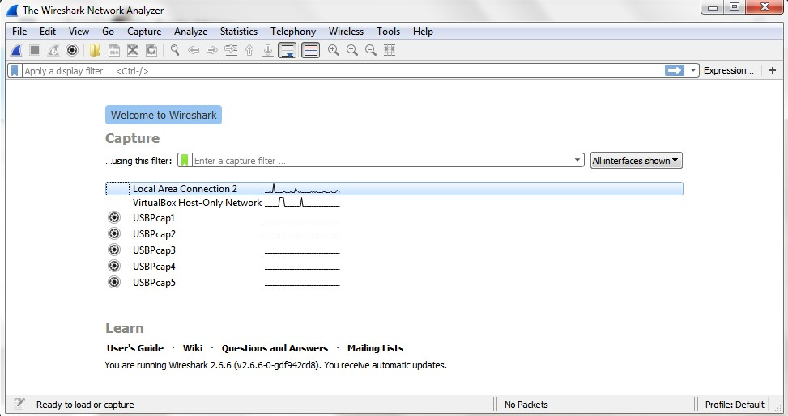

As soon as you single-click on your network interface’s name, you can see how the packets are working in real time. Wireshark will capture all the packets going in and out of our systems.

Promiscuous mode is the mode in which you can see all the packets from other systems on the network and not only the packets send or received from your network adapter. Promiscuous mode is enabled by default. To check if this mode is enabled, go to Capture and Select Options. Under this window check, if the checkbox is selected and activated at the bottom of the window. The checkbox says “Enable promiscuous mode on all interfaces”.

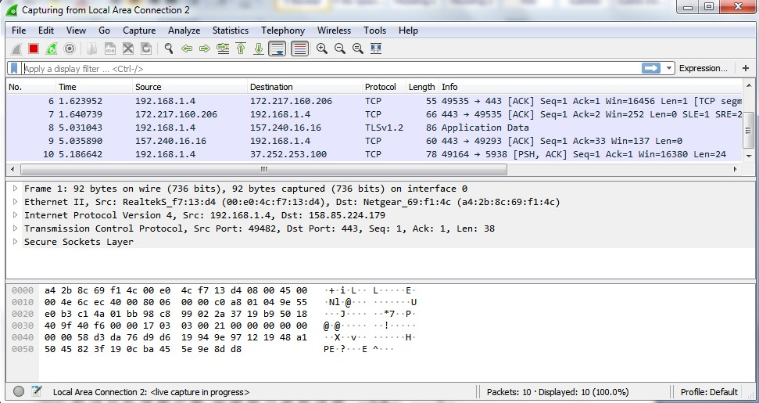

The red box button “STOP” on the top left side of the window can be clicked to stop the capturing of traffic on the network.

**Color Coding**

Different packets are seen highlighted in various different colors. This is Wireshark’s way of displaying traffic to help you easily identify the types of it. Default colors are:

Light Purple color for TCP traffic

Light Blue color for UDP traffic

Black color identifies packets with errors – example these packets are delivered in an unordered manner.

To check the color coding rules click on View and select Coloring Rules. These color coding rules can be customized and modified to fit your needs.

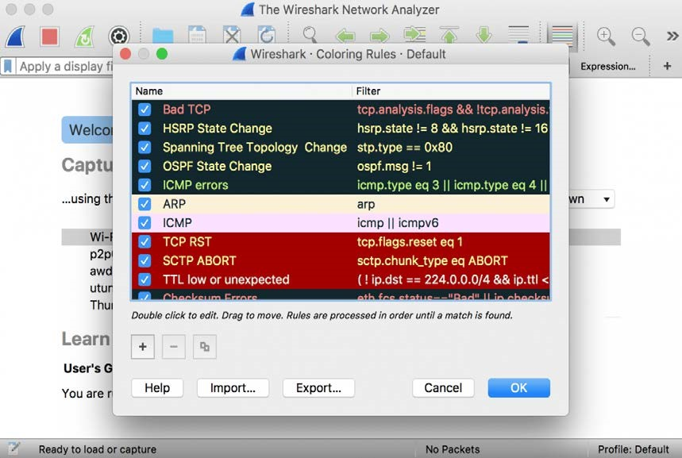

**Analyze the captured Packets:**

First of all, click on a packet and select it. Now, you can scroll down to view all its details.

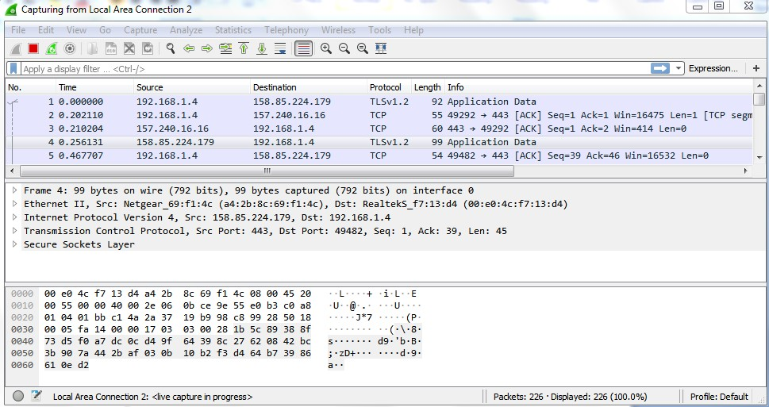

Filters can also be created from here. Right-click on one of any details. From the menu select Apply as Filter drop-down menu so filter based on it can be created.

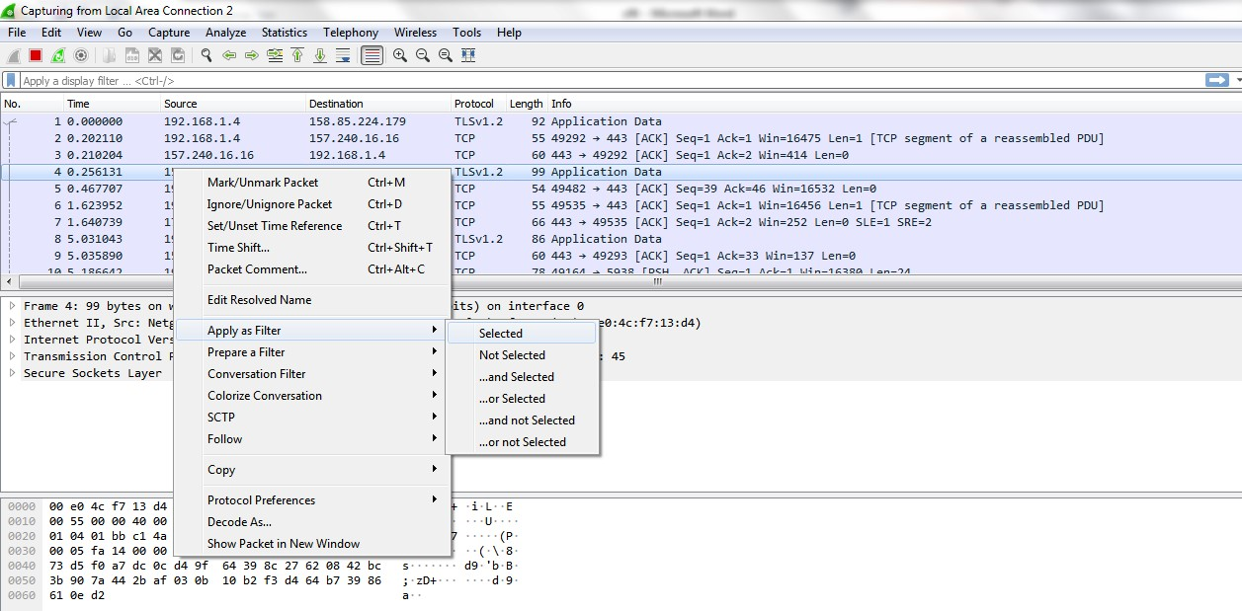

**Display filter command –**

1. Display packets based on specific IP-address

➢ip.addr == 192.0.2.1

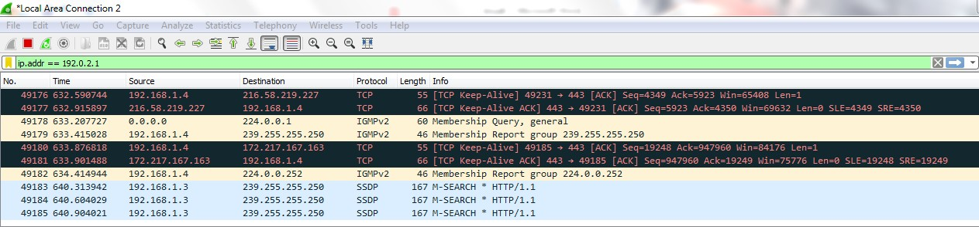

1. Display packets which are coming from specific IP-address

➢ip.src == 192.168.1.3

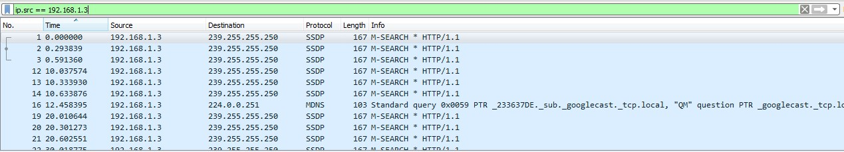

1. Display packets which are having specific IP-address destination

➢ip.dst == 192.168.1.1

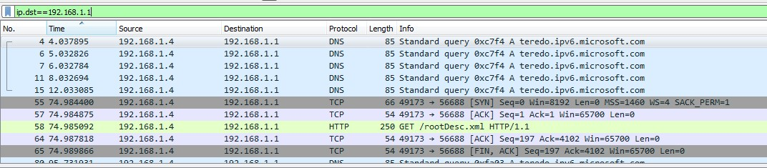

1. Display packets which are using http protocol

➢http

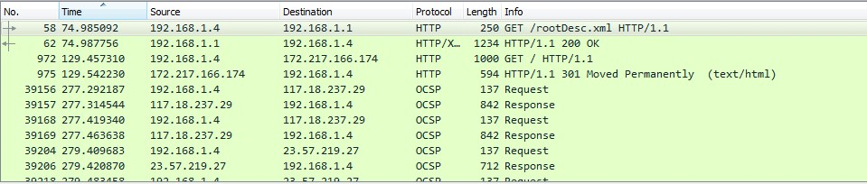

1. Display packets which are using http request
   * http.request

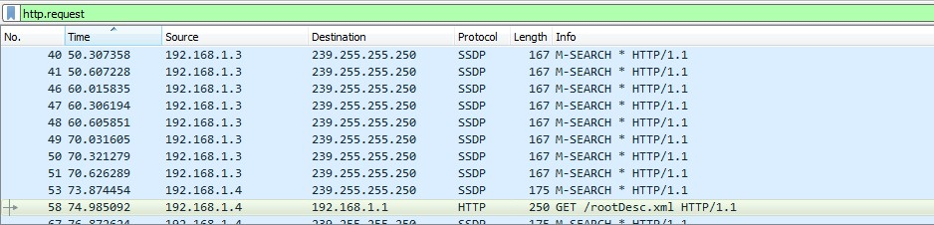

1. Display packets which are using TCP protocol
   * tcp

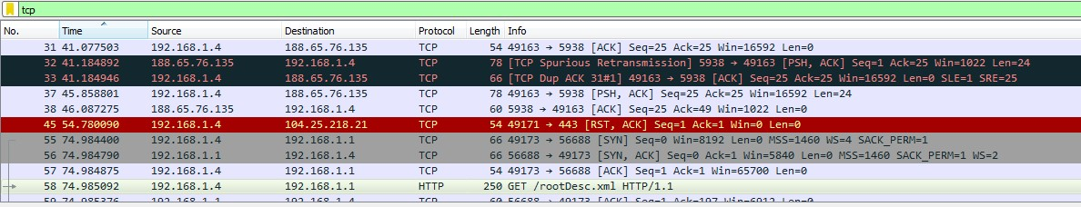

1. Display packets having no error connecting to server
   * http.response.code==200

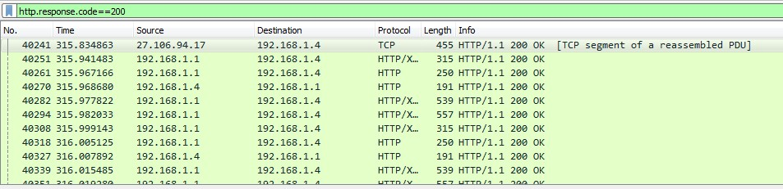

1. Display packets having port number 80

➢tcp.port==80 || udp.port==80

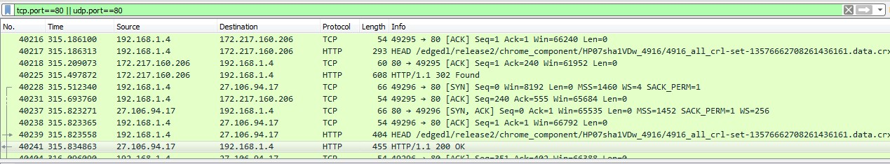

1. Display packets which that contains keyword facebook

➢tcp contains facebook

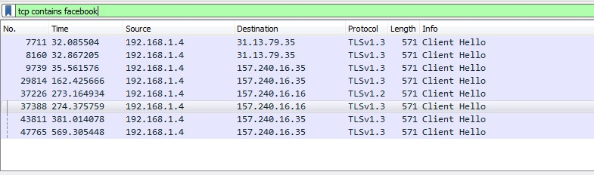

# PRACTICAL 5

# Aim:Analyze the packets provided in lab and solve the questions using Wireshark:

* What web server software is used by www.snopes.com?
* About what cell phone problem is the client concerned?
* According to Zillow, what instrument will Ryan learn to play? - How many web servers are running Apache?

1. **What web server software issued by www.snopes.com?**

**Analysis –** The domain name be found from host header so we will set host header column where we will see all domain name. Select any HTTP request and expand the Hypertext Transfer Protocol then right click on Host header and then Apply as Column.

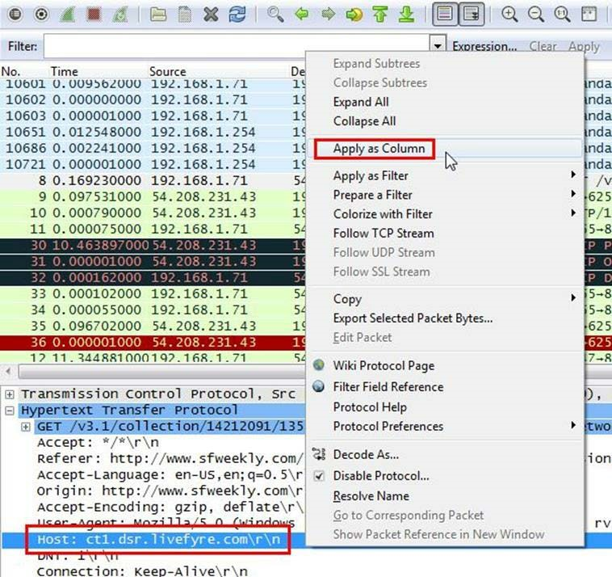

Now we can see our host www.snopes.com in host column.

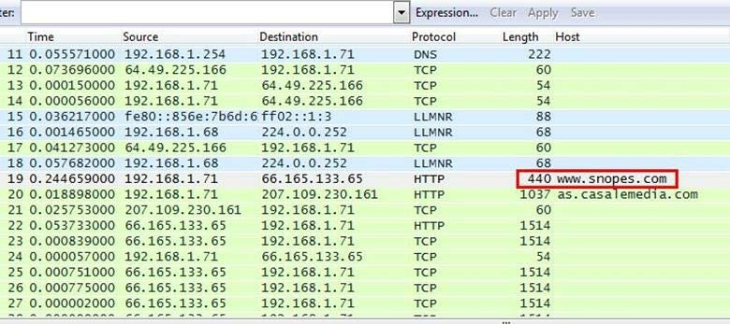

Right click on the selected packet and then select Follow TCP stream.

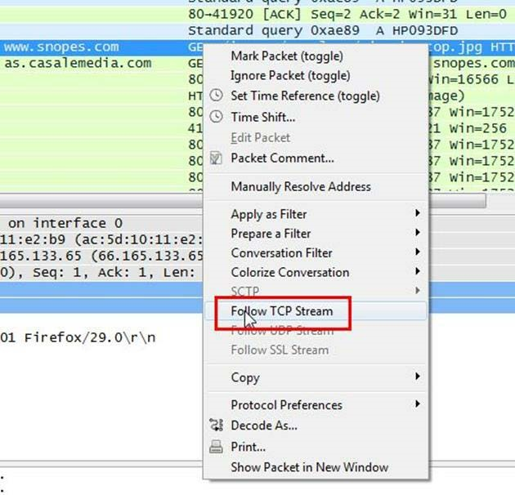

Now we can see the webserver name in server header it is Microsoft IIS 5.0

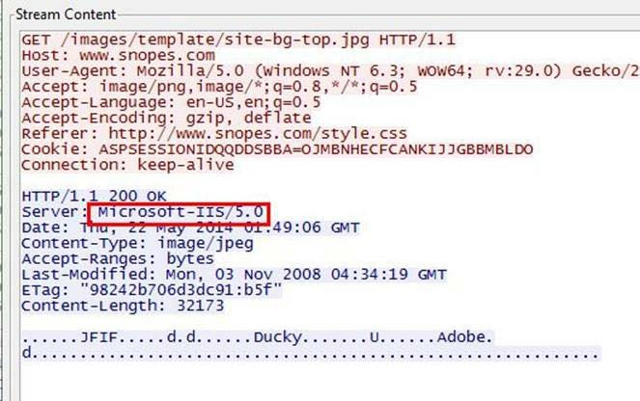

1. **About what cell phone problem is the client concerned?**

**Analysis –** Client talking about cell so we search for cell keyword in whole packets. We will use regular express for searching the cell keyword. Apply frame matches “(?!) cell”

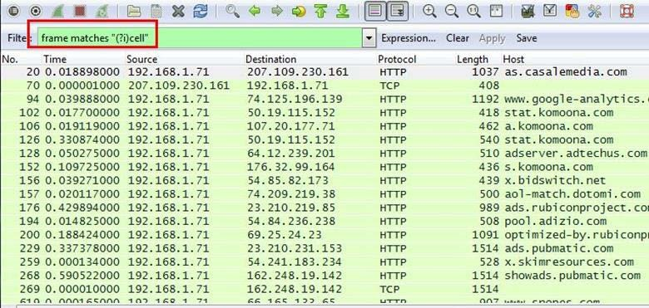

After applying the filter now, we will start to check every HTTP request. We noticed in the first HTTP request cell keyword is in URL and it was about cell phone charging issue.

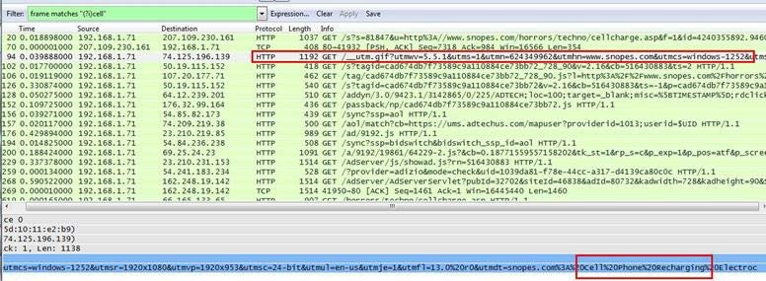

1. **According to Zillow, what instrument will Ryan learn to play?**

Analysis – As we did in the last challenge, we will apply a regular express filter for the Zillow keyword. Apply frame matched “(?!) zillow”

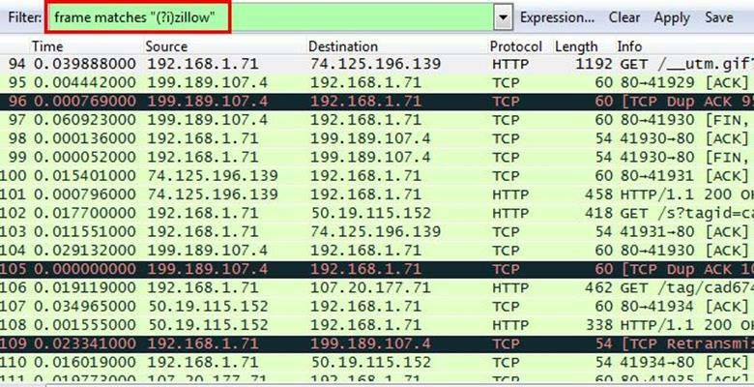

After applying the filter, we found only one packet with the Zillow keyword

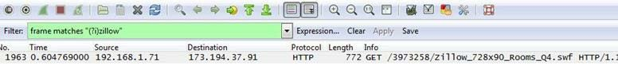

Select the packet and expand the Hypertext Transfer Protocol tab right click on it go to Protocol Preferences and check Allow subdissector to resemble TCP stream.

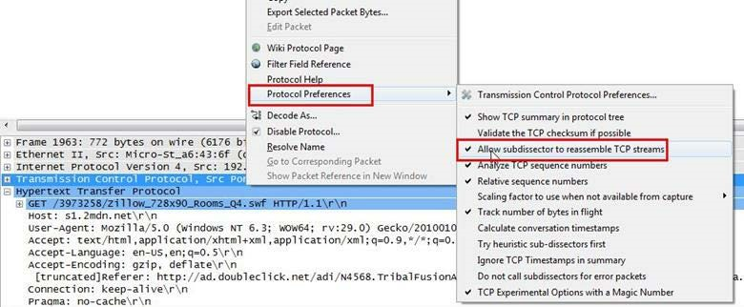

Now go to file and select Export Objects > HTTP. It will save all objects from the packet.

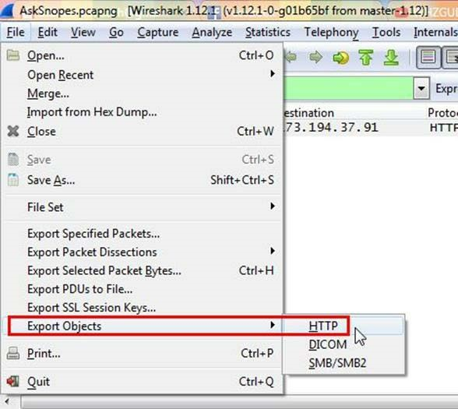

Click on save all.

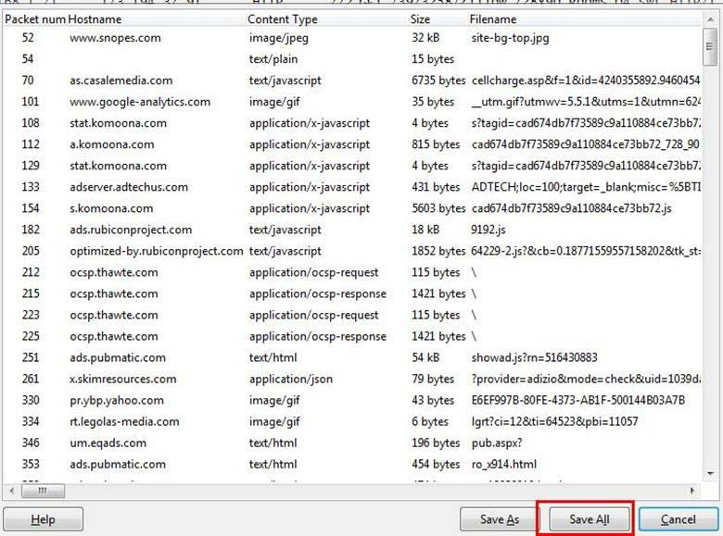

After saving all files in a directory and we found a swf file with name Zillow.

After opening the flash file, we saw that Zillow was trying to learn saxophone.

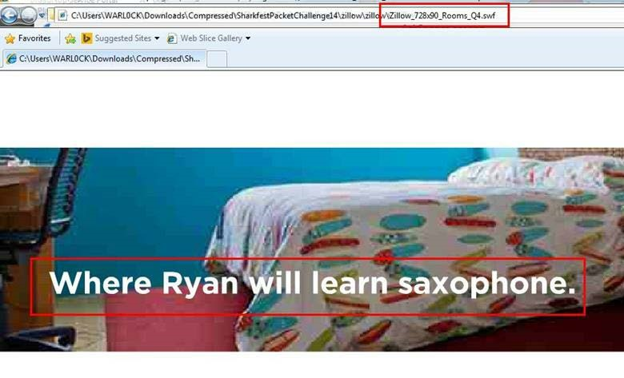

**4. How many web servers are running Apache?**

**Analysis –** The web server name can be retrieved from HTTP response header. So will apply filter http. response and we can see all http response packets.

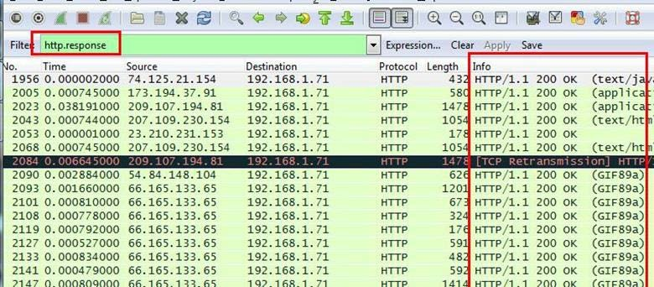

Now we will set the server header as column select any packet and right click on it then select Apply as Column.

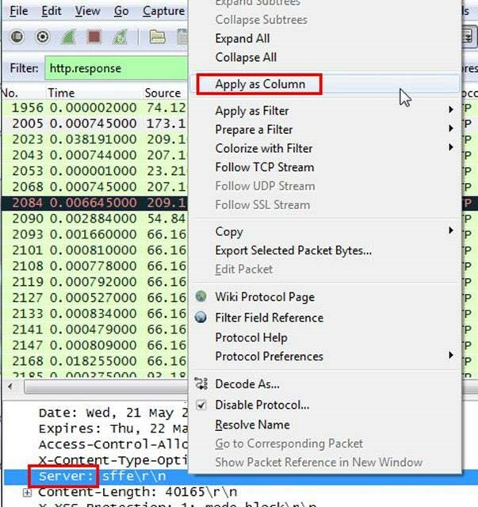

Now can see the server column where all server name is showing.

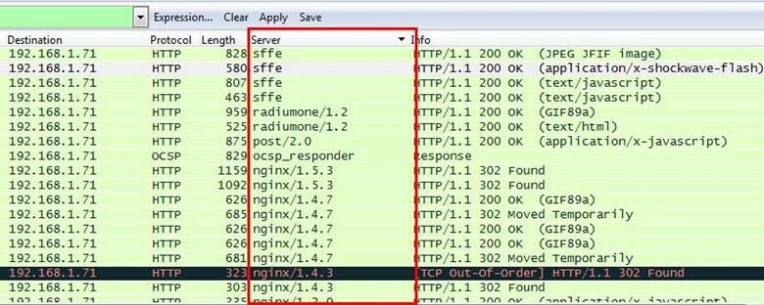

Now we have to check how many Apache packets are there we can’t count manually for each packet so we will apply another filter http.server contains “Apache”

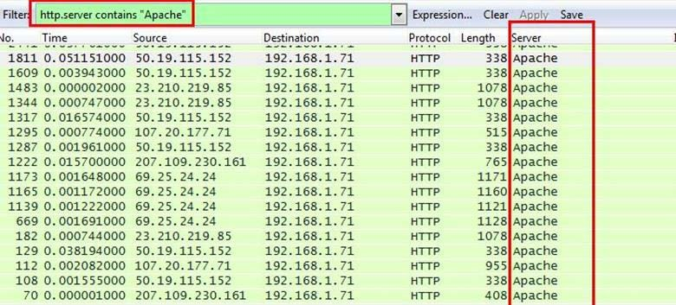

After applying filter go to Statistics > Endpoints

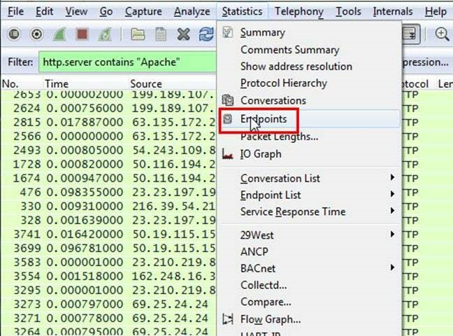

It will show all connections

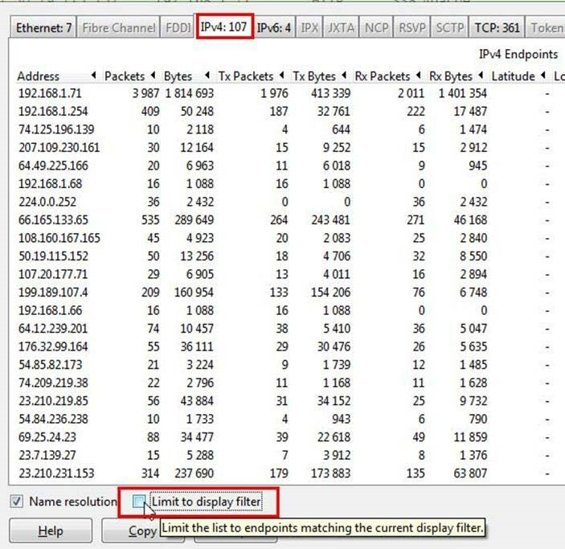

Check the limit to display filter then it will show the actual Apache connections. Now there are showing 22 connections but will exclude 192.168.1.71 because it is client’s IP not a server IP so there are actual 21 Apache servers.

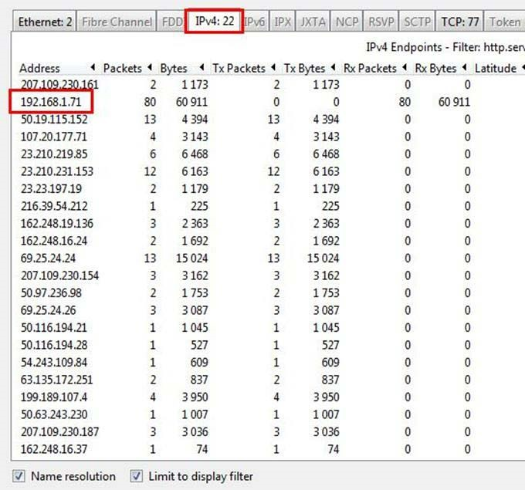

**CONCLUSION:** We have successfully analyzed the packets provided and solved the questions using wireshark.

# PRACTICAL 6

**Aim:** Using Sysinternals tools for Network Tracking and Process Monitoring:

Check Sysinternals tools

* Monitor Live Processes
* Capture RAM
* Capture TCP/UDP packets
* Monitor Hard Disk
* Monitor Virtual Memory
* Monitor Cache Memory

**INFO:**Windows Sysinternals is a website which offers technical resources and utilities to manage, diagnose, troubleshoot, and monitor a Microsoft Windows environment.

* + **Check Sysinternals tools :**Windows Sysinternals tools are utilities to manage, diagnose, troubleshoot, and monitor a Microsoft Windows environment.

The following are the categories of Sysinternals Tools:

* 1. File and Disk Utilities
  2. Networking Utilities
  3. Process Utilities
  4. Security Utilities
  5. System Information Utilities
  6. Miscellaneous Utilities
  + **Monitor Live Processes : (Tool: ProcMon)**

**To Do:**

* 1. Filter (Process Name or PID or Architecture, etc)
  2. Process Tree
  3. Process Activity Summary
  4. Count Occurrences

**Output:**

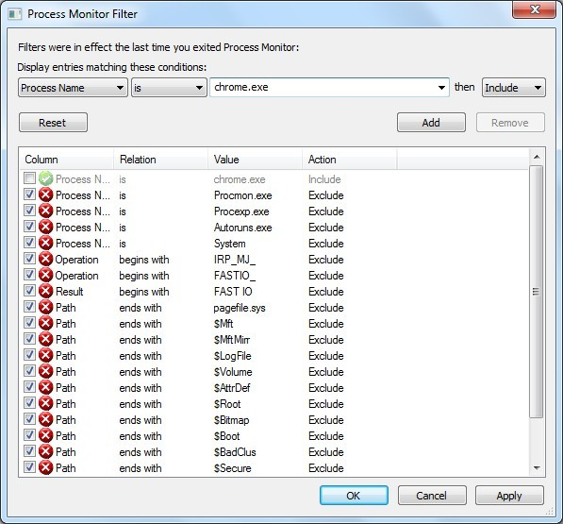

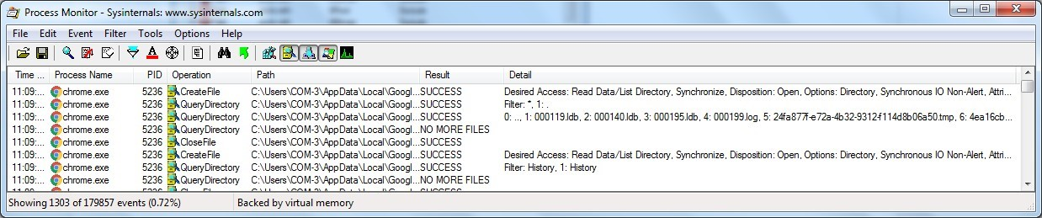

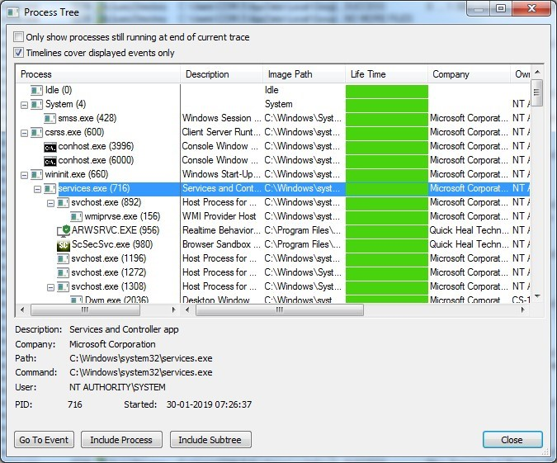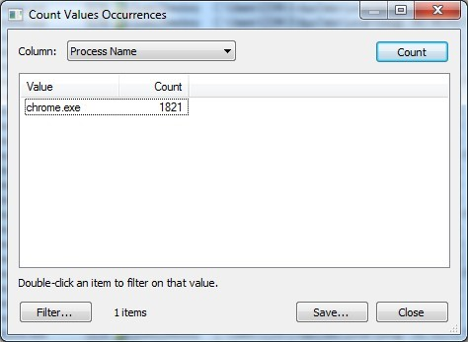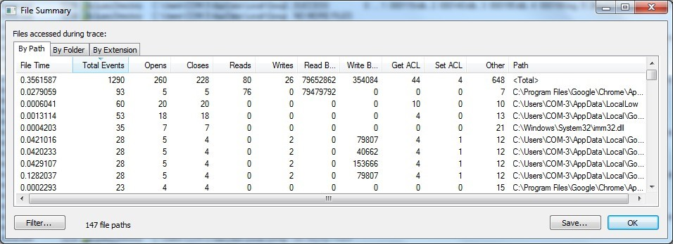

* + **Capture RAM (Tool: RAMCapture)**

**To Do:**

* + 1. Click Capture
    2. Creates a .mem file of the system memory (RAM) utilized.

**Output:**

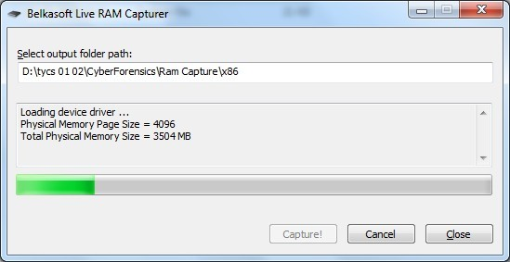

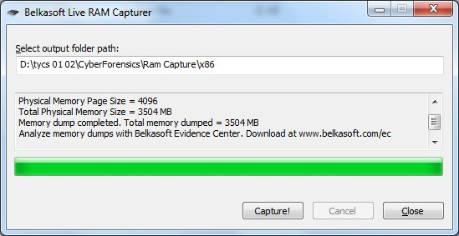

**Capture TCP/UDP packets (Tool: TcpView) :**

**To Do:** 1. Save to .txt file.

2. Whois

**Output:**

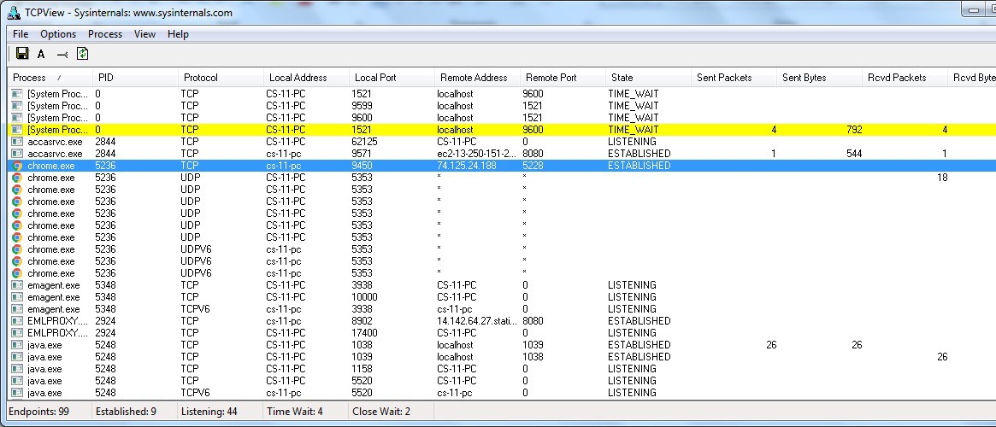

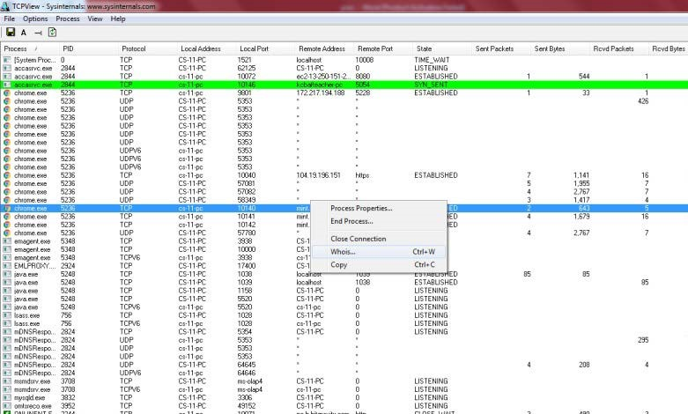

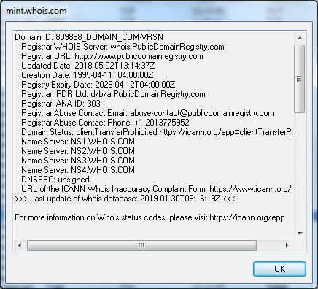

**Monitor Hard Disk (Tool: DiskMon) :**

**To Do:**

* 1. Save to .log file.
  2. Check operations performed in the disk as per time and sectors affected.

**Output :**

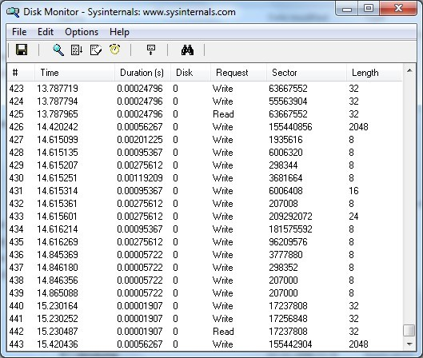

**Monitor Virtual Memory ( Tool : VMMAP) :**

**To Do:**

1. Options – Show Free & Unusable Regions 2. File-> Select Process e.g. chrome.exe

3. Save to .mmp file.

**Output :**

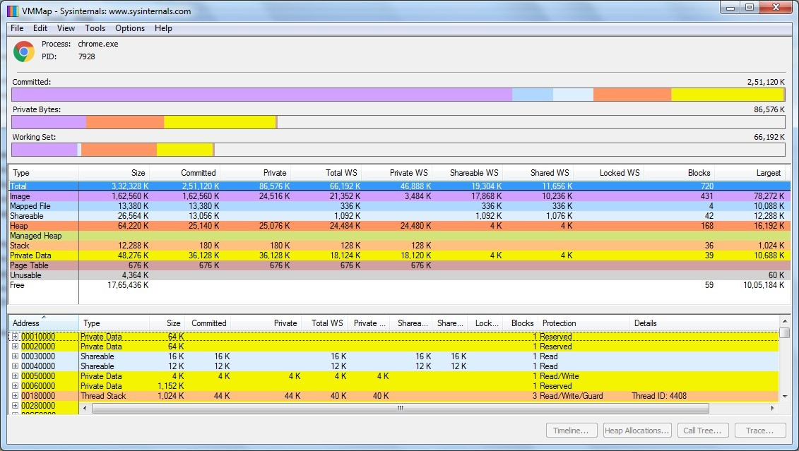

**Monitor Cache Memory**

**(Tool: RAMMap)**

**TO DO :**

1.Save to .RMP file.

**Output:**

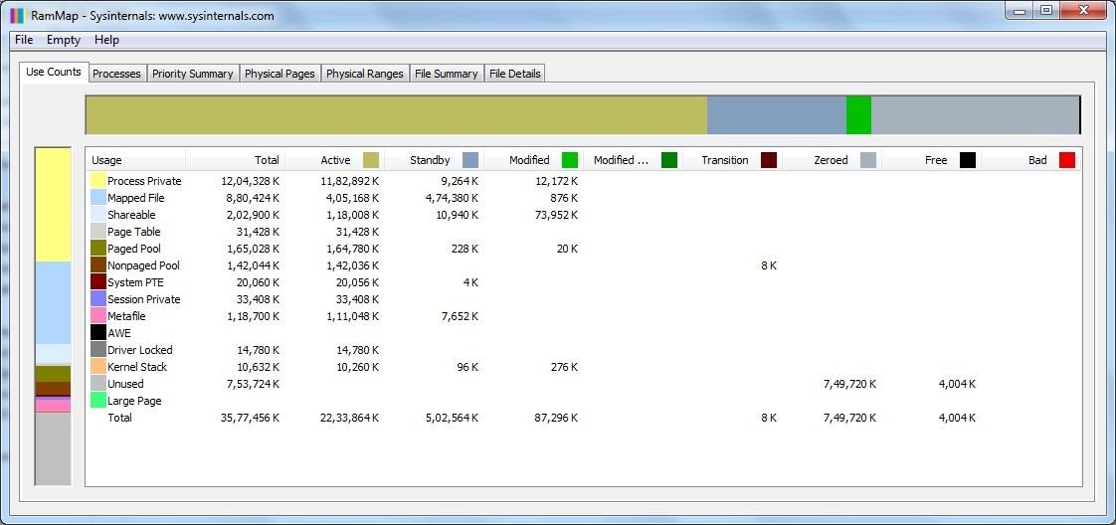

**PRACTICAL 7**

**AIM :** Recovering and Inspecting deleted files

* Check for Deleted Files
* Recover the Deleted Files
* Analyzing and Inspecting the recovered files

Step 1: Start Autopsy from Desktop.

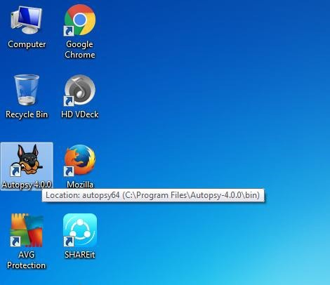



Step 2: Now create on New Case.

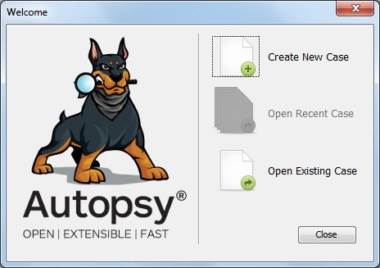

Step 3: Enter the New case Information and click on Next Button.

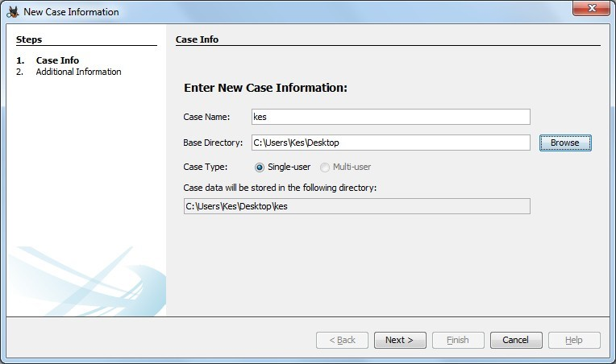

Step 4: Enter the additional Information and click on Finish.

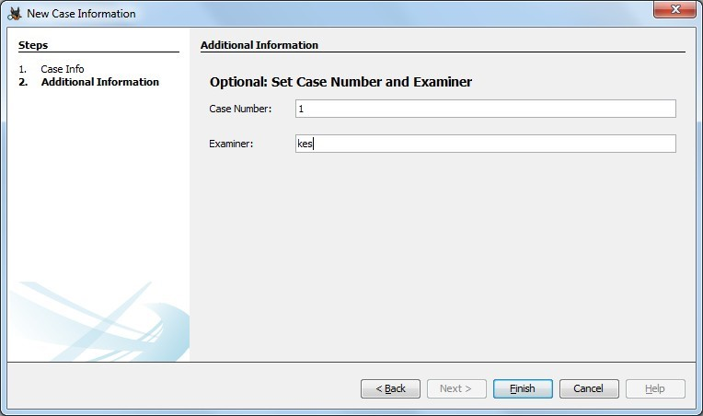

Step 5: Now Select Source Type as Local disk and Select Local disk form drop down list and click on Next.

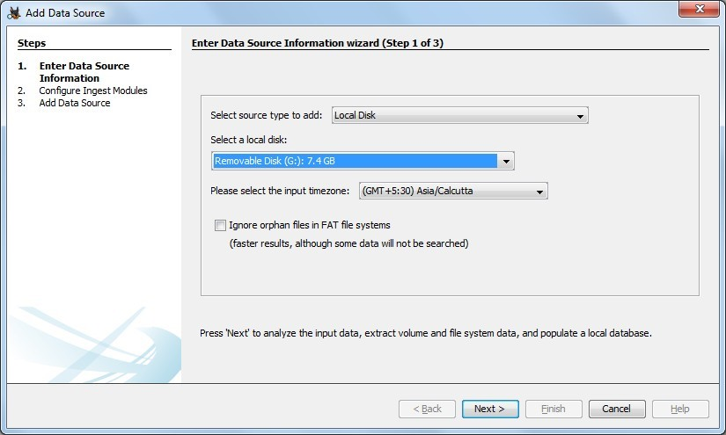

\

Step 6: Click on Next Button.

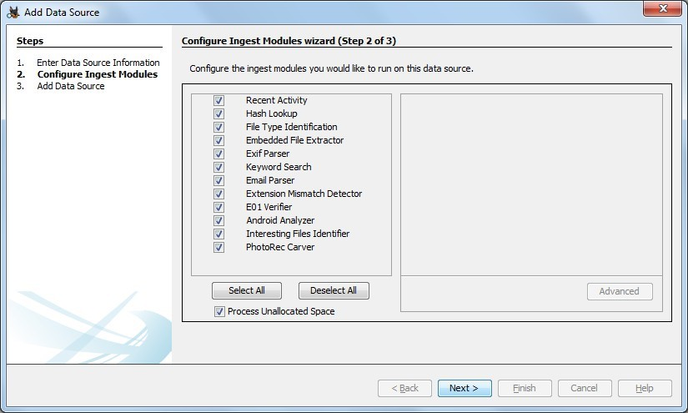

Step 7: Now click On Finish.

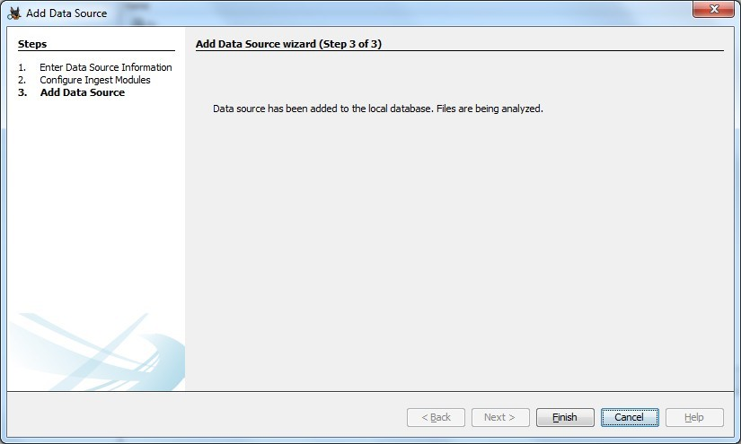

Step 8: Now Autopsy window will appear and it will analyzing the disk that we have selected.

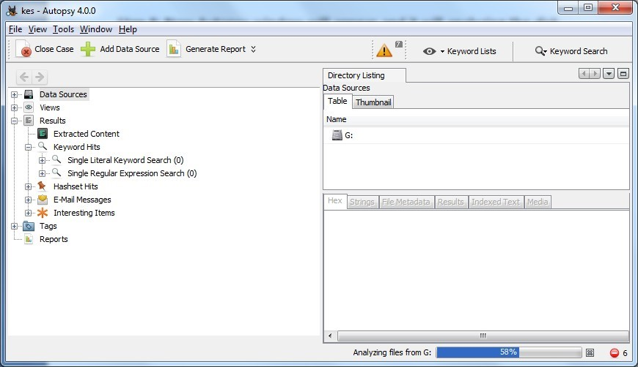

Step 9: All files will appear in table tab select any file to see the data.

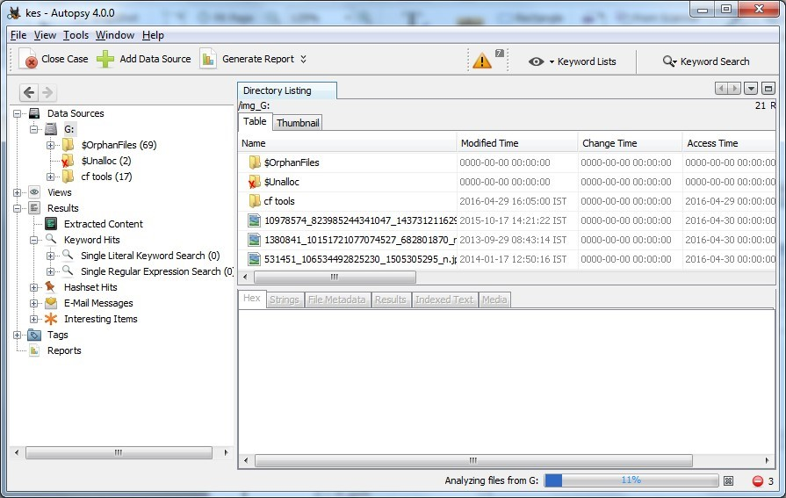

Step 10:Expand the tree from left side panel to view the document files.

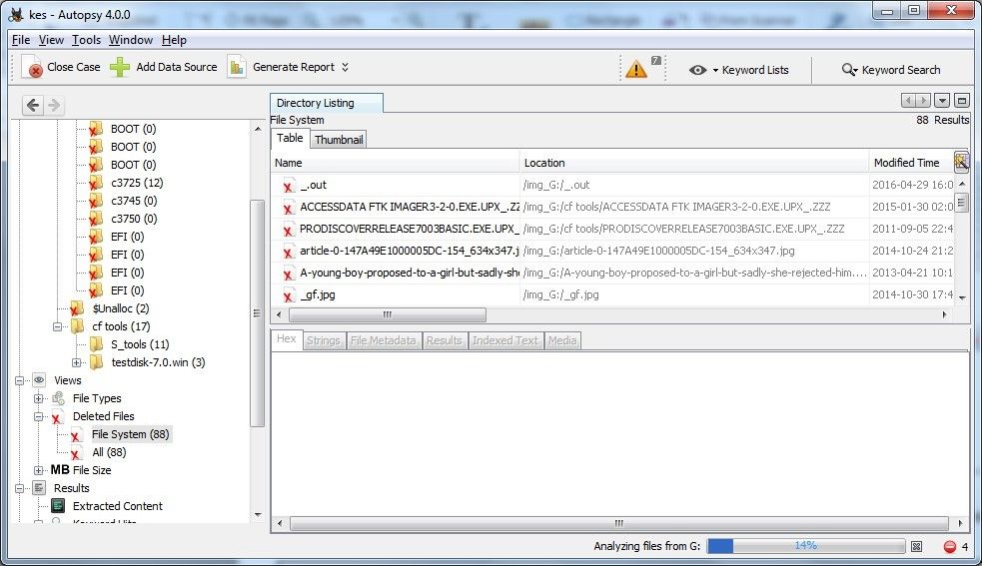

Step 11: To recover the file, go to view node-> Deleted Files node , here select any file and right click on it than select Extract Files option.

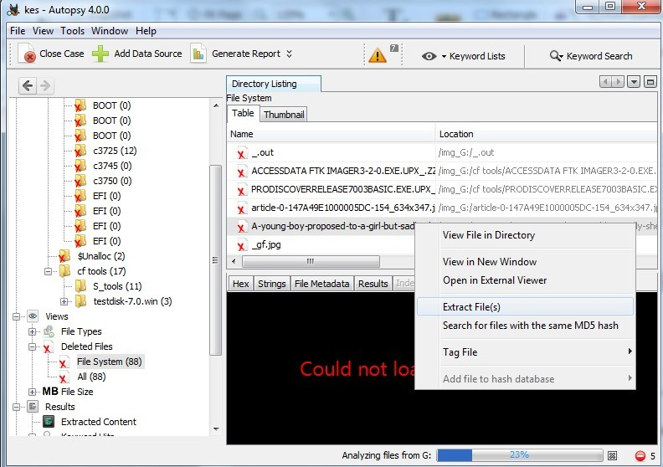

Step 12: By default Export folder is choose to save the recovered file.

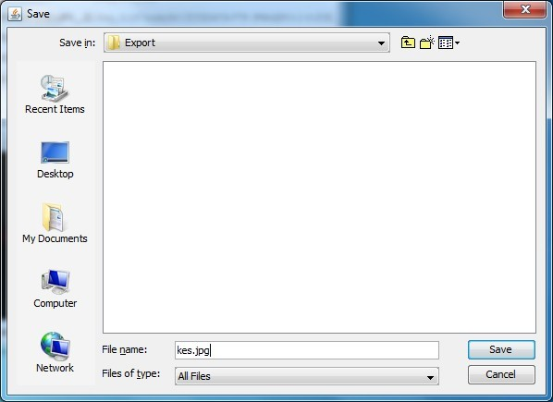

Sep 13 : Now Click on Ok.

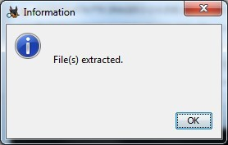

Step 14: Now go to the Export Folder to view Recover file.

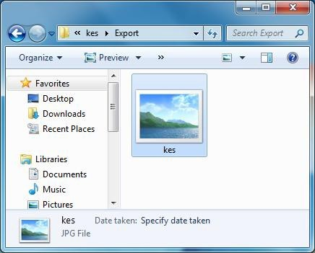

Step 15: Click on Generate Report from autopsy window and Select the Excel format and click on next.

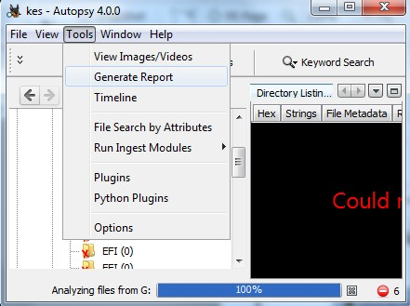

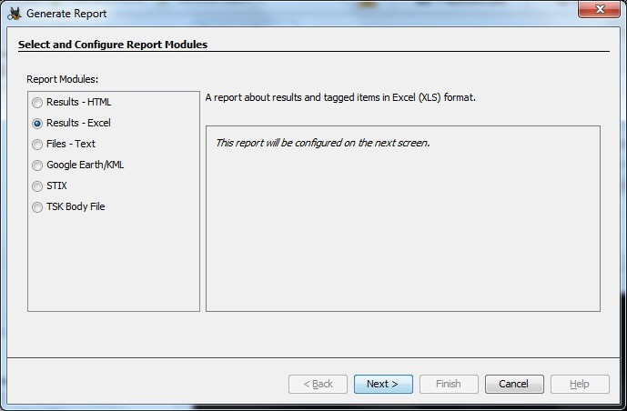

Step 16: Now Report is Generated So click on close Button .we can see the Report on Report Node.

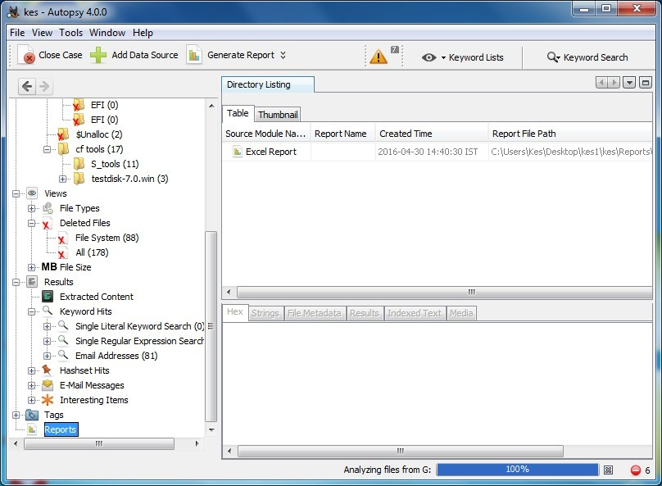

Step 17: Now open the Report folder and Open Excel File.

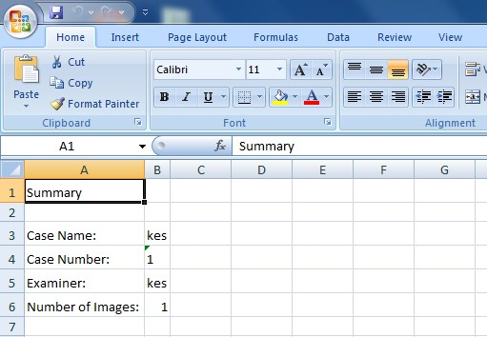

# PRACTICAL 8

**Aim:** Acquisition of Cell phones and Mobile devices.

**INFO:**MOBILedit Forensic is a digital forensics product by Compelson Labs that searches, examines and report on data from GSM/CDMA/PCS cell phone devices. MOBILedit connects to cell phone devices via an Infrared port, a Bluetooth link, Wi-Fi, or a cable interface

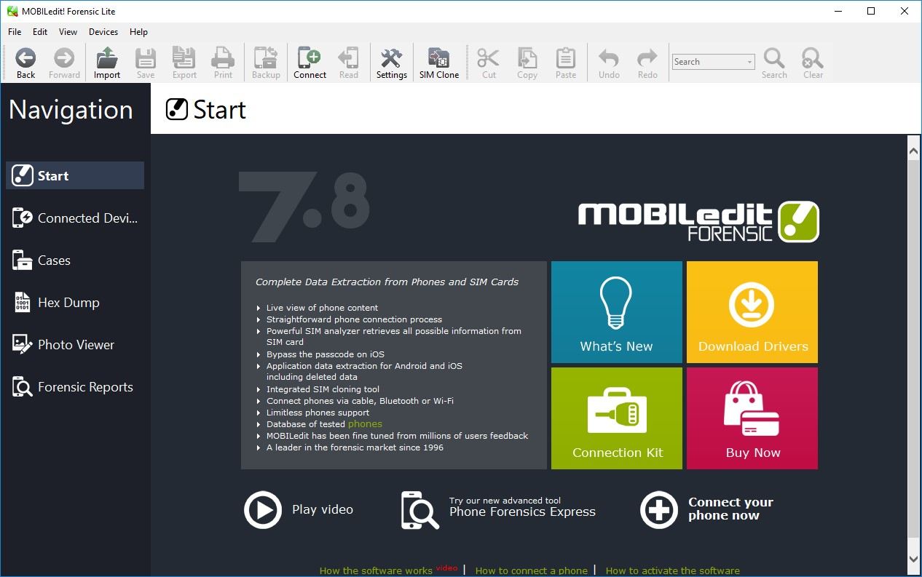

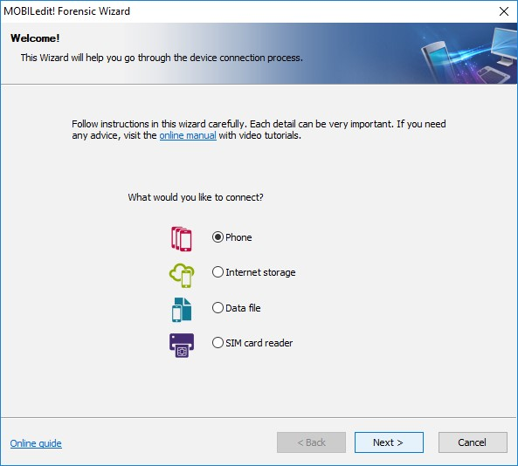

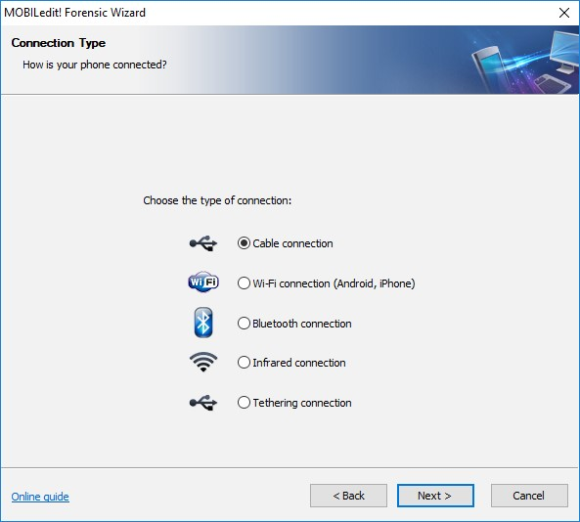

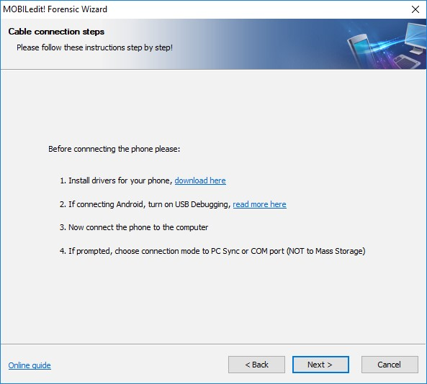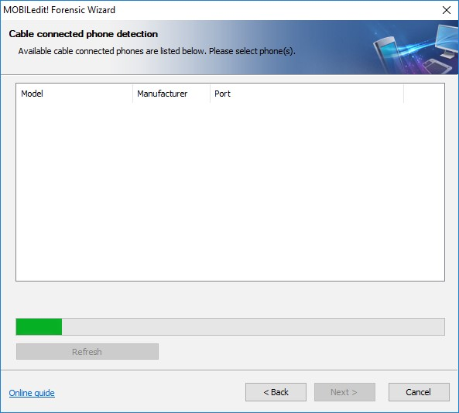

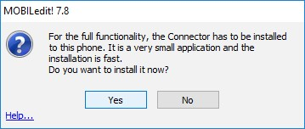

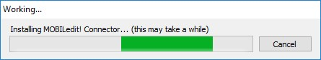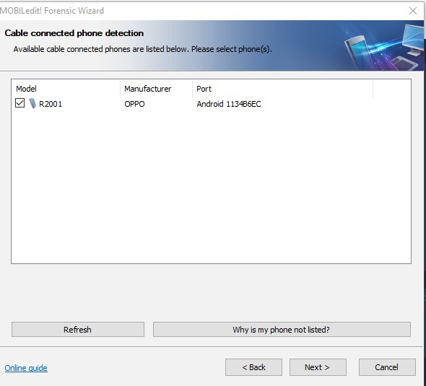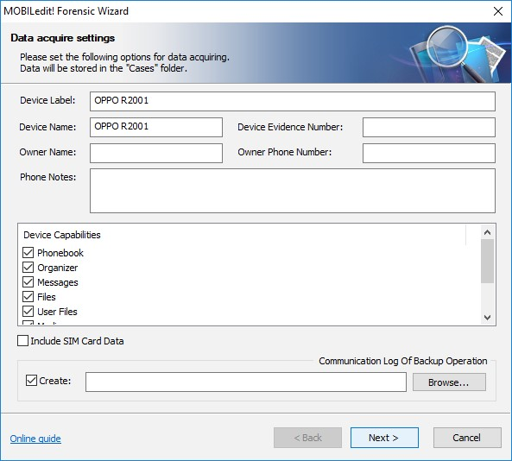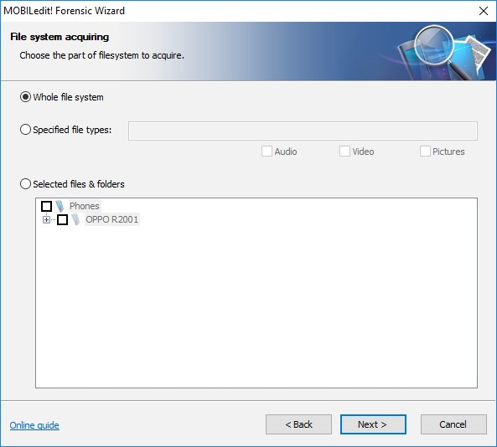

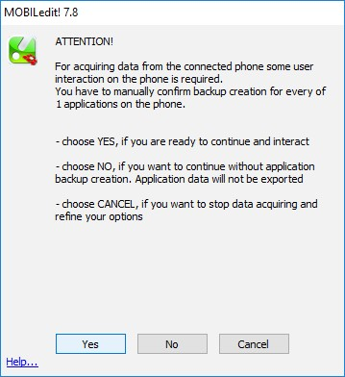

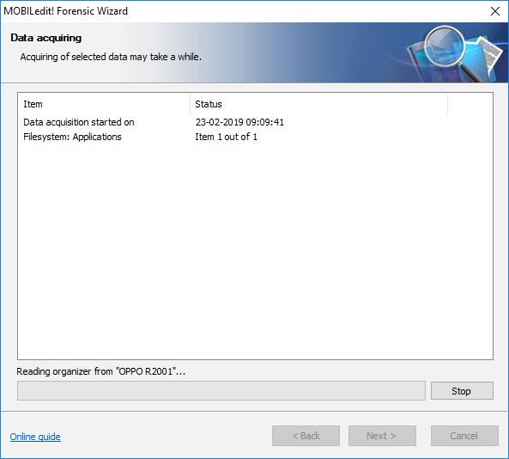

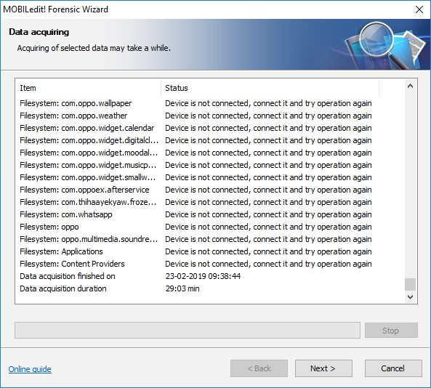

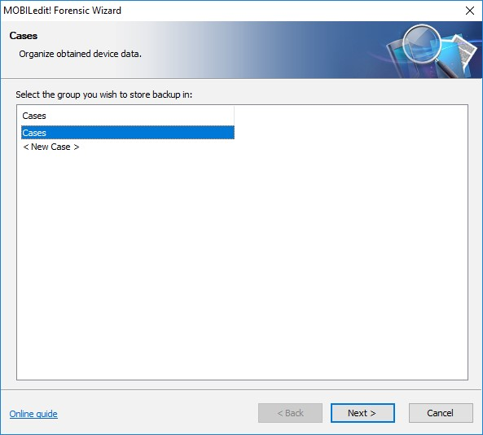

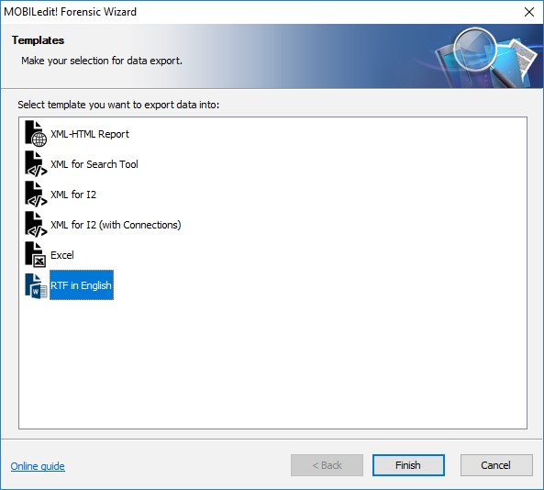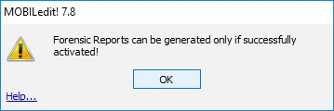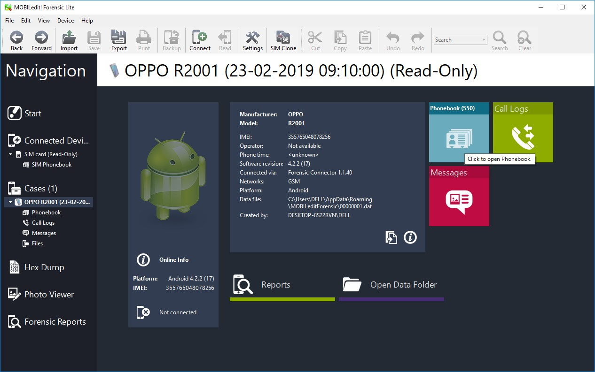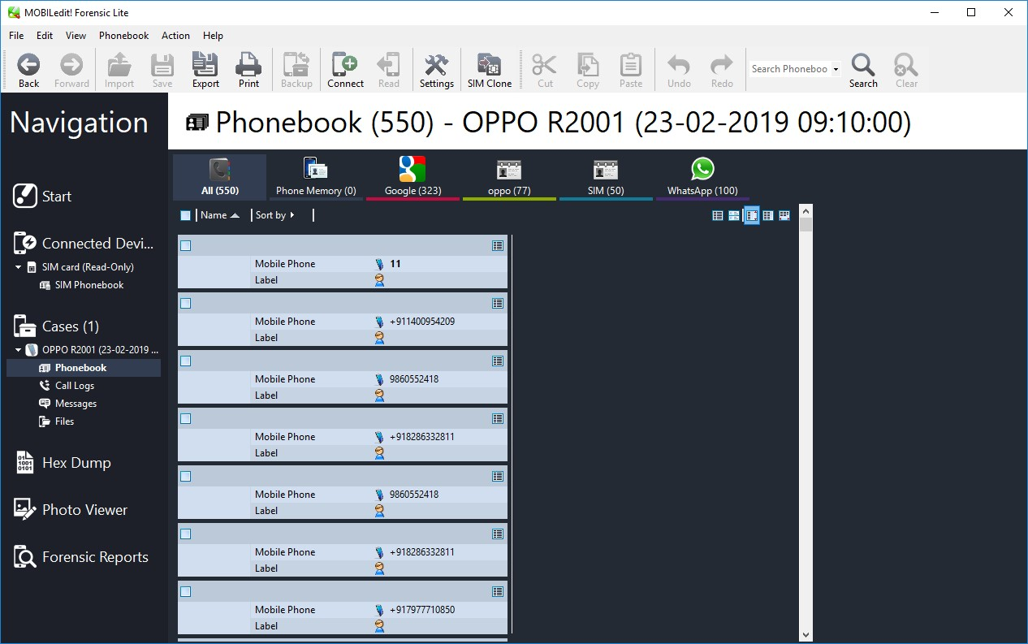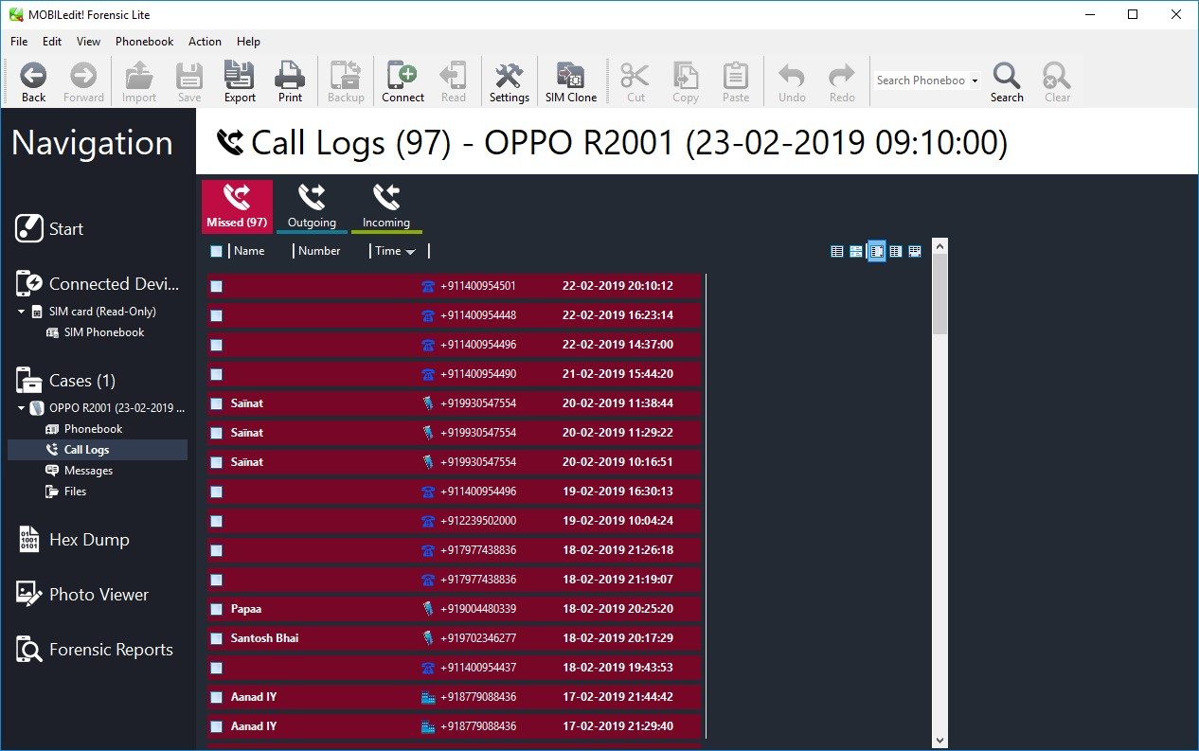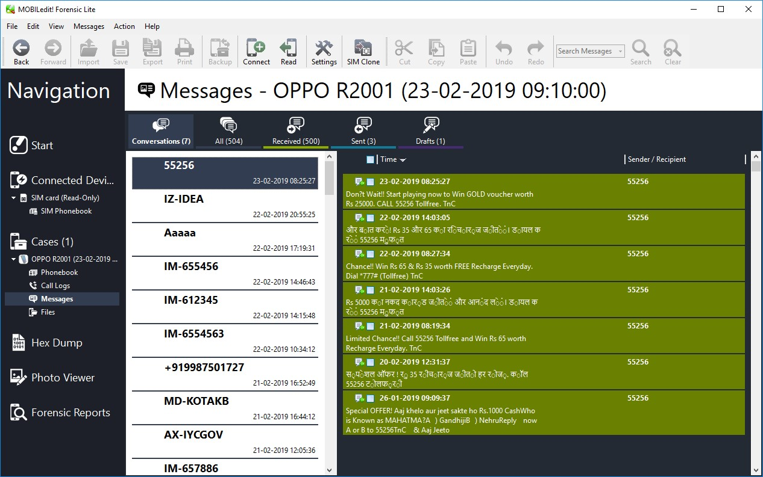

# PRACTICAL 9

**Aim:** Email Forensics

* Mail Service Providers
* Email protocols
* Recovering emails
* Analyzing email header

**INFO: FTK** **Imager** is a data preview and imaging tool used to acquire data (evidence) in a forensically sound manner by creating copies of data without making changes to the original evidence.

FTK can filter or find files specific to e-mail clients and servers. You can configure these filters when you enter search parameters.

Because of Jim’s responses to a poor performance review, the CEO of Superior Bicycles,Martha Dax, suspects he might have obtained sensitive information about the company’s business model that he’s leaking to a competitor.

Martha asked her CIO, to have an IT employee copy the Outlook .pst file from Jim Shu’s old computer to a USB drive.

To process this investigation, we need to examine the Jim_shu’s.pst file, locate the message, and export it for further analysis of its header to see how Jim might have received it.

**Recovering Email**

Start AccessData FTK and click **Start a new case**, then click **OK**. Click **Next** until you reach the **Refine Case - Default** dialog box Click the **Email Emphasis** button , and then click **Next .**

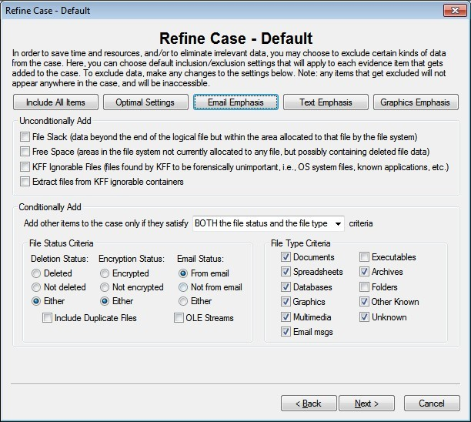

Click **Next** until you reach the **Add Evidence to Case** dialog box, and then click the **Add Evidence** button.

In the Add Evidence to Case dialog box, click the **Individual File** option button, and then click **Continue**.

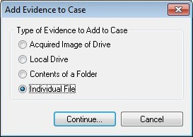

In the **Select File** dialog box, navigate to your work folder, click the **Jim_shu’s.pst file**, and then click **Open**.

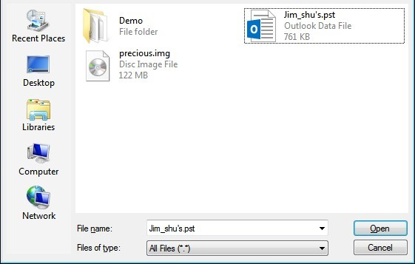

When the **Add Evidence to Case** dialog box opens, click **Next**. In the **Case summary** dialog box, click **Finish**.

When FTK finishes processing the file, in the main FTK window, click the **E- mail Messages** button, and then click the **Full Path** column header to sort the records.

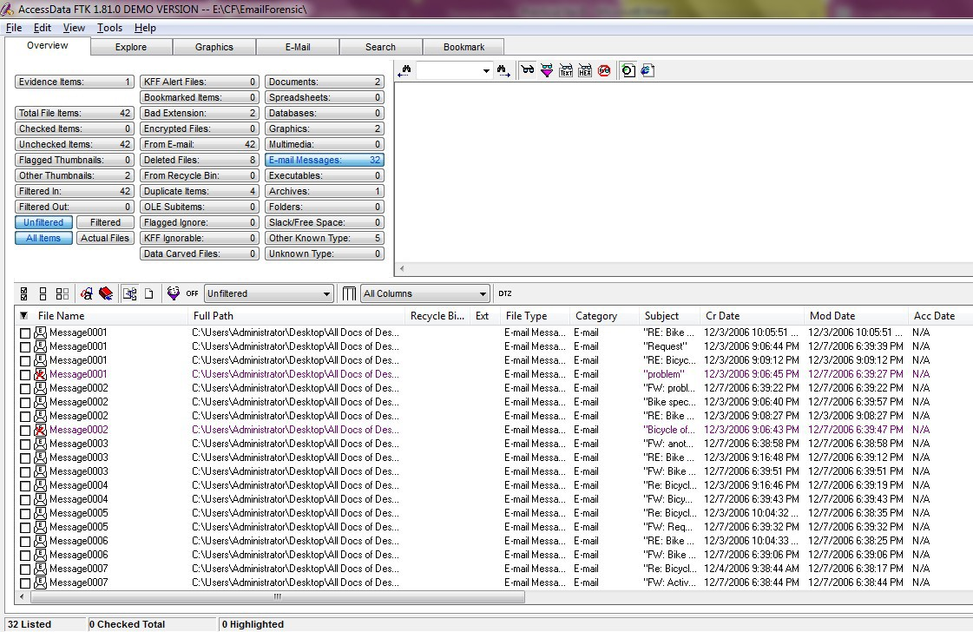

**For email recovery follow following steps:**

Click the **E-Mail** tab. In the tree view, click to expand all folders, and then click the **Deleted Items** folder.

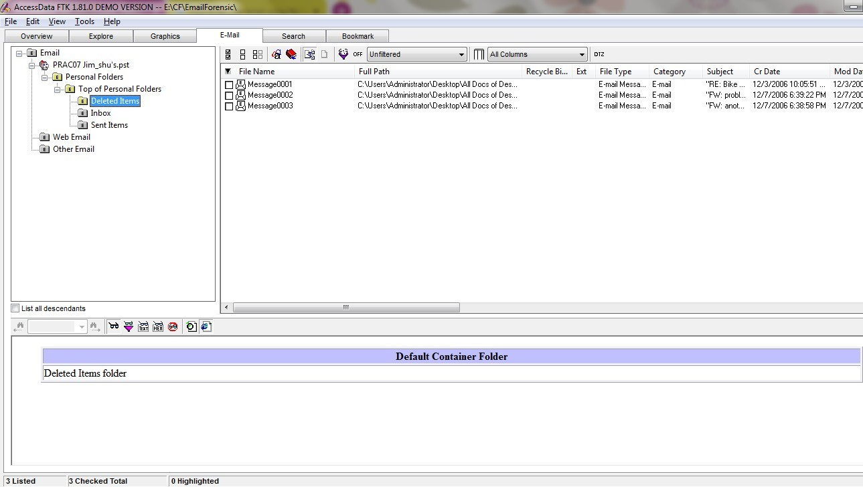

Select any message say Message0001 right click and select option Launch.

Detached Viewer and you can see detail of deleted message.

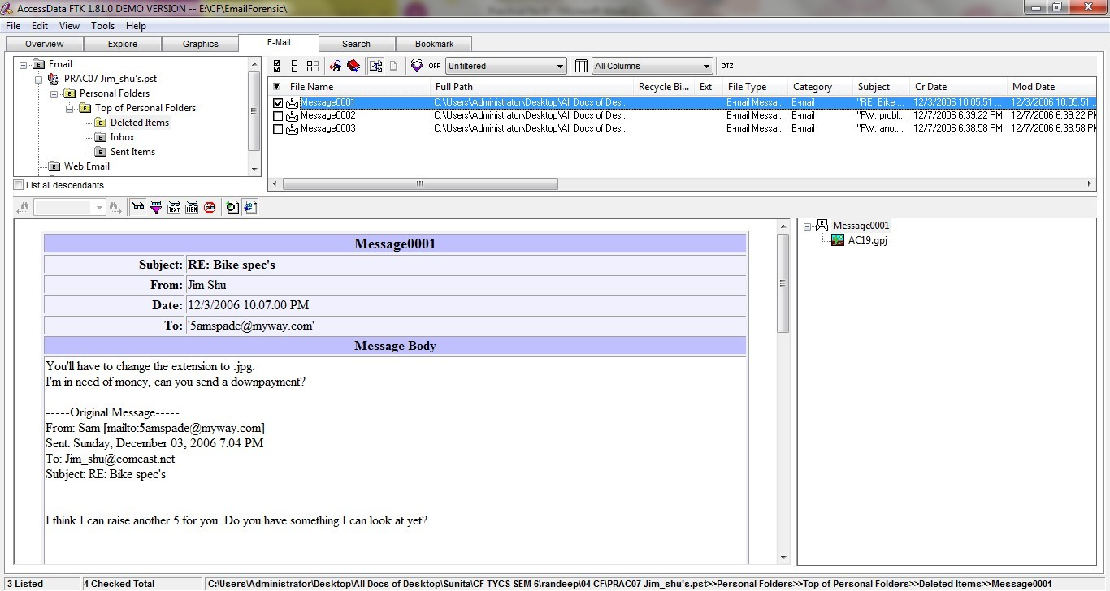

**For analyzing header follow following steps:**

Click the **E-Mail** tab. In the tree view, click to expand all folders, and then click the **Inbox** folder.

In the File List pane at the upper right, click Message0003; as shown in the pane at the bottom, it’s from **Sam** and is addressed to **Jim_shu@comcast.net.**

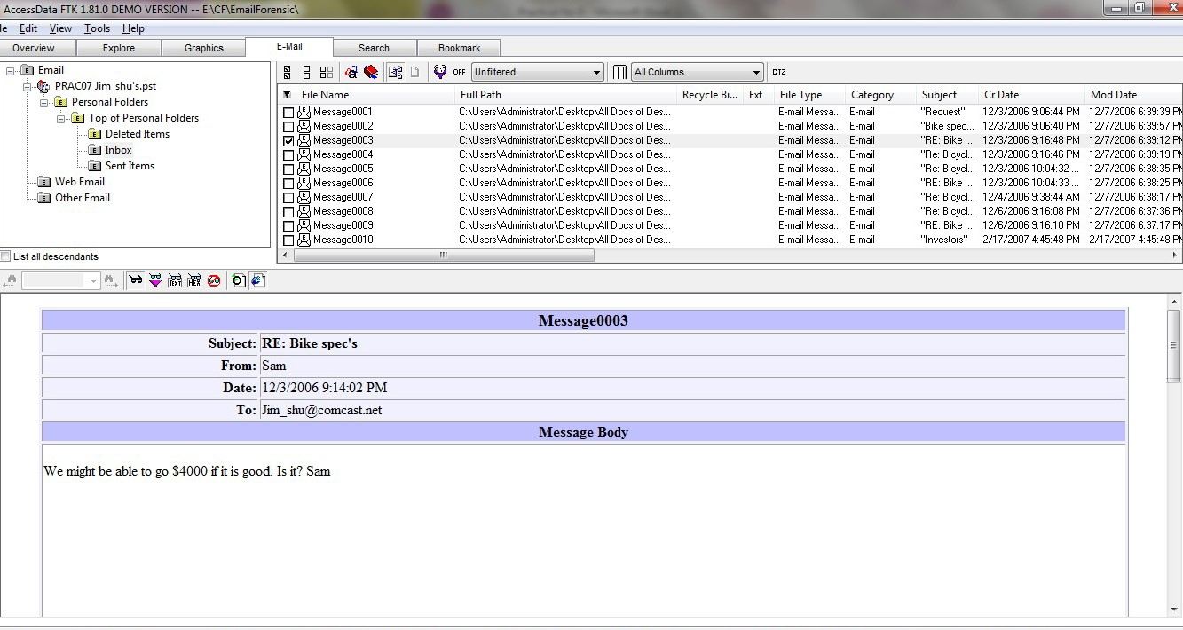

Right-click on any message say Message0003 in the File List pane and click Export File. In the Export Files dialog box, click OK.

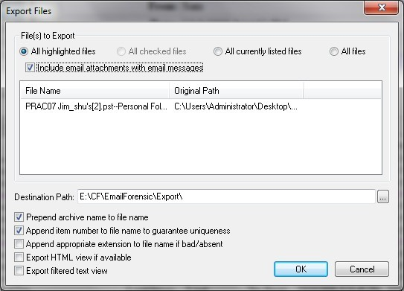

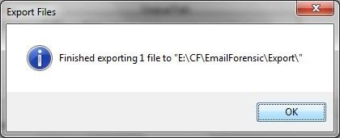

FTK saves exported files in the HTML format with no extension.

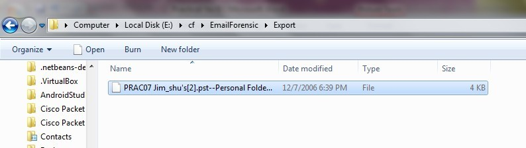

Right-click the Message0003 file and click Rename. Type Message0003.html and press Enter.

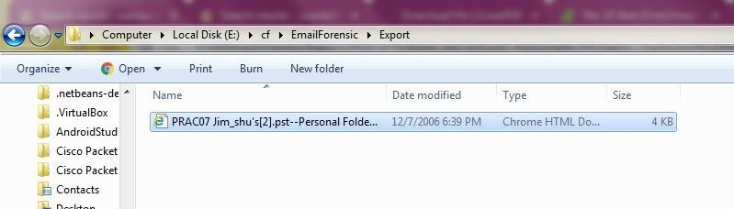

Double-click Message0003.html to view it in a Web browser.

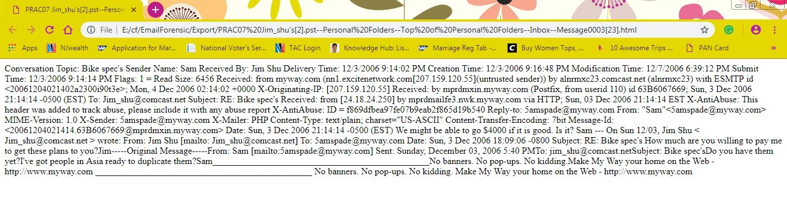

# PRACTICAL 10

**Aim:** Web Browser Forensics.

-Web Browser working

-Forensics activities on browser

-Cache / Cookies analysis

-Last Internet activity

**INFO:**Browser History Examiner (BHE) is a forensic software tool for capturing,  
analysing and reporting internet history from the main desktop web browsers. BHE can assist in various digital investigations such as civil & criminal digital forensics cases,  
security incidents, human resources investigations and general employee activity reporting.

**Steps:**

1. Open BrowserHistoryExaminer.

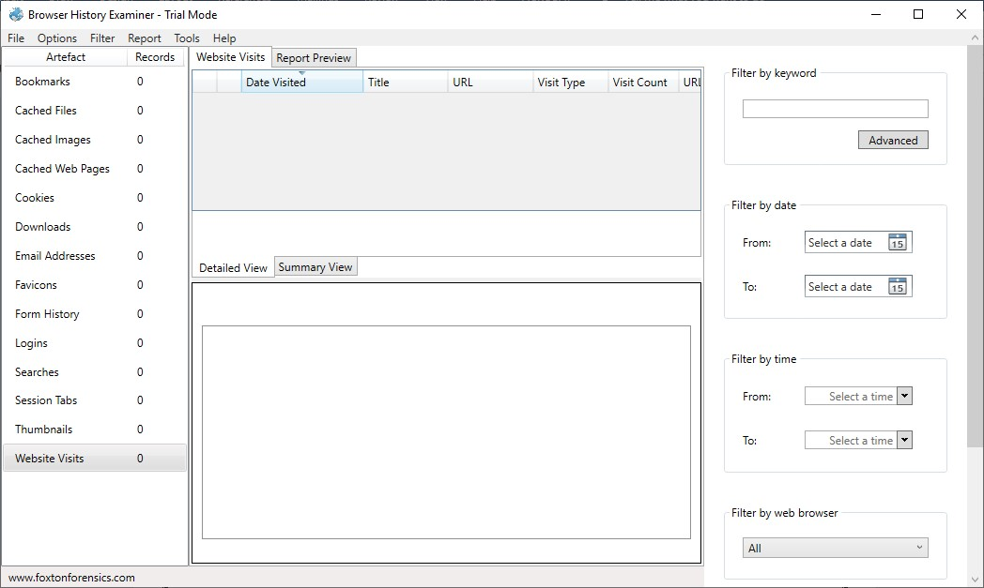

1. Click on file > Capture History

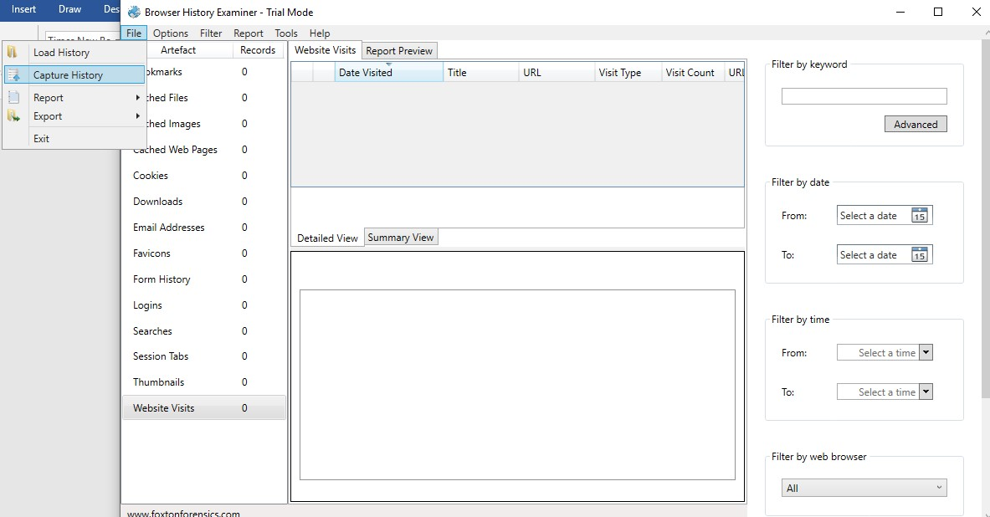

1. Select the capture folder and click on next.

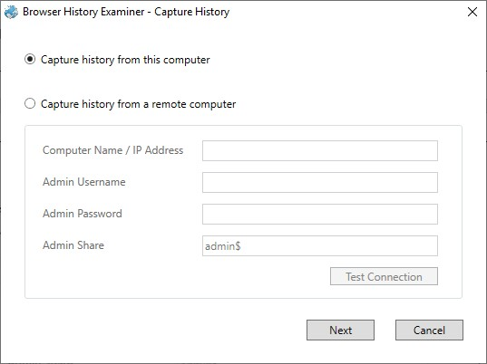

1. Enter the destination to capture the data.

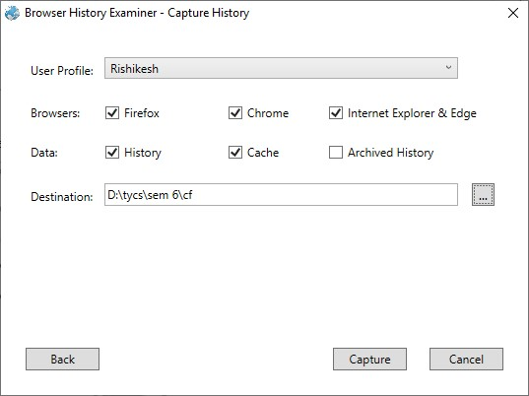

1. The History is been extracting.

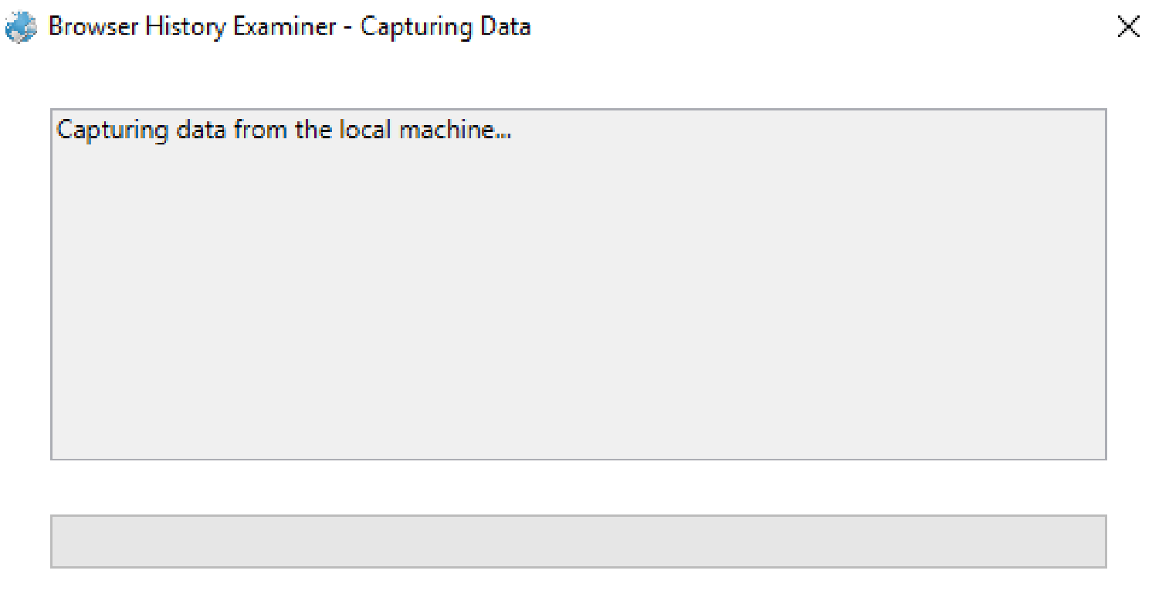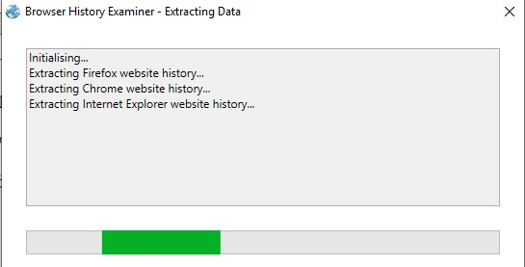

1. The data has been retrieved.

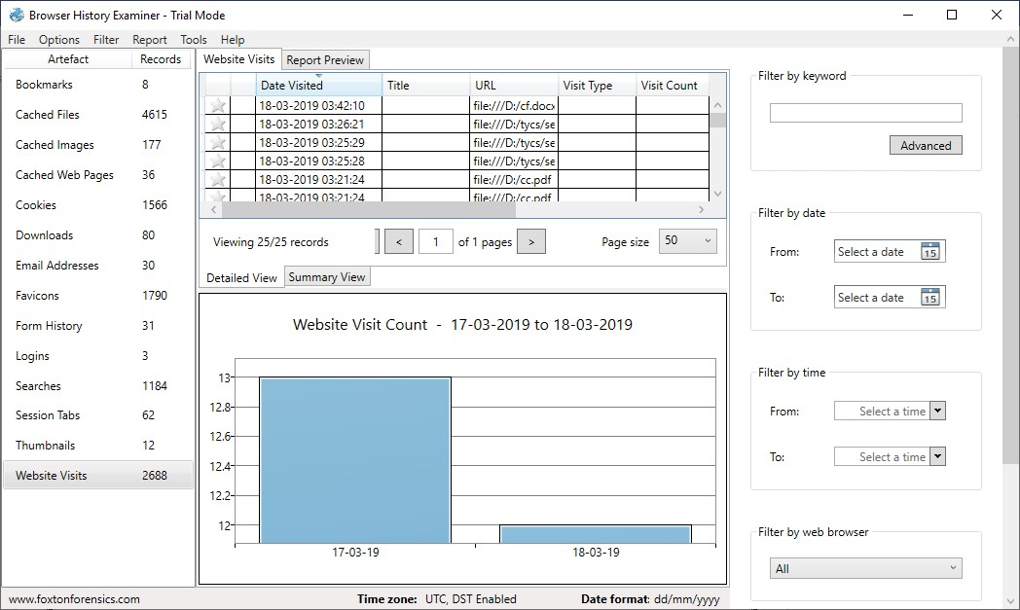

1. On the left panel click on bookmarks.

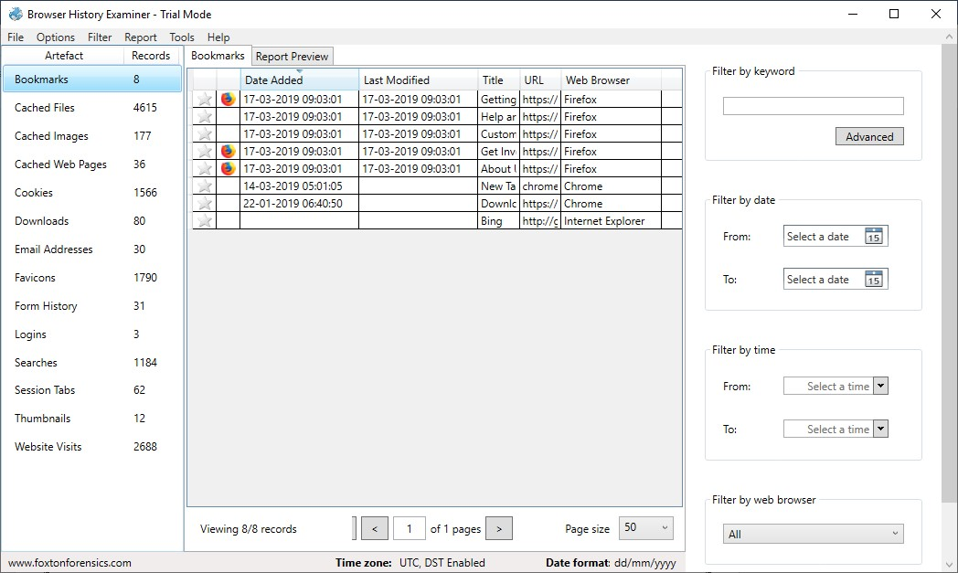

1. On the left panel click on cached files.

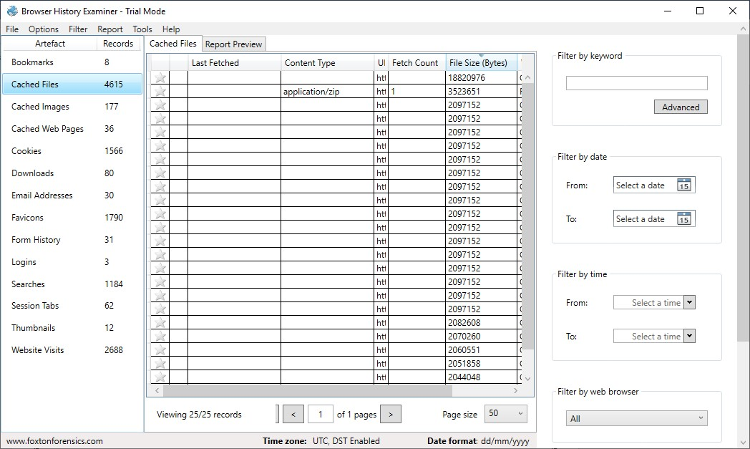

1. On the left panel click on cached images.

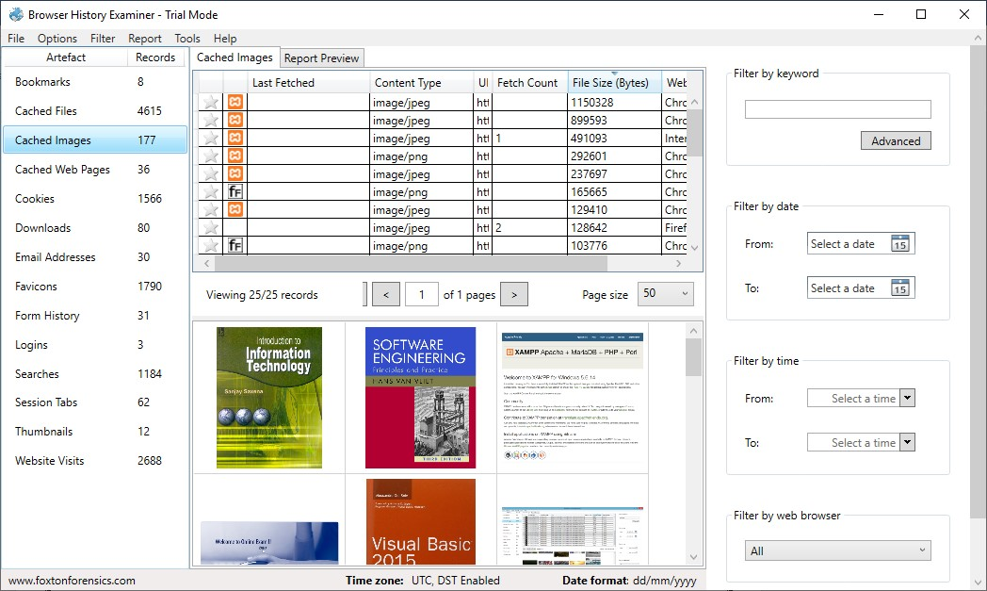

1. On the left panel click on cookies.

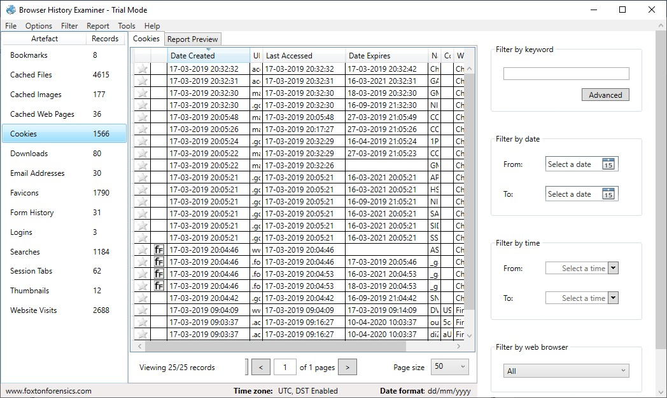

1. To Create Reports. Click on file > Report and save the report as pdf or html page.

